**Student Affairs/Support System at various Renowned Institutes**

**Of**

***Madhya Pradesh,India***

**Date**:February 09,2015

***Created By:***

*Vaibhav Sabharwal*

[*https://sites.google.com/site/vaibhavsabharwal300*](https://sites.google.com/site/vaibhavsabharwal300)

*Varun Wadhwani*

[*https://sites.google.com/site/varunwadhwani324*](https://sites.google.com/site/varunwadhwani324)

**Chapter 1**

**Grievance & Redressal Mechanism**

**Grievance/Complaint’** - A “Grievance/Complaint” is defined as any communication that expresses dissatisfaction about an action or lack of action, about the standard of service/deficiency of service of an institute and the complainant asks for remedial action. **(src ..1)**

**Grievance Redressal**- Grievance Redressal Mechanism is part and parcel of the machinery of any administration. No administration can claim to be accountable, responsive and user-friendly unless it has established an efficient and effective grievance redress mechanism. In fact, the grievance redress mechanism of an organization is the gauge to measure its efficiency and effectiveness as it provides important feedback on the working of the administration.**(src ..2)**

**(src..3)**

* The redressal mechanism would act as a platform where a student can not only lodge complaints against any irregularities in the admission process, withhold or refusal to return any document or certificates, but can also lodge complaints of harassment and victimization including sexual harassment.
* Any institute having its own Grievance Redressal system is an informal manner i.e. through direct supervision of the Principal. But in a formal sense along with the provision of Online Feedback suggestion Form and Online Grievance Cell.
* The Grievance Redressal cell of the institute functions with the following purposes; to ensure a democratic environment in the campus, to acquaint all the faculty, Student about their rights and duties, to solve the various personal and educational related grievances of the teacher Student to make the institution student friendly, and to ensure the qualitative as well as quantitative development of the institution through the grievance and redressal cell.
* Moreover, considering the nature and depth of the grievances due inquiry is made by the members of the cell, and through personal discussion the matter is solved. If anybody is found to be guilty of any kind of nuisance he or she is given punishment with due consideration with the principal.
* The nature of punishment includes verbal as well as written warning, information to the parents, financial punishment, information to the police (if the situation arises for so) and expelling from the institute as per the rule.

***Generalised Model of Grievance Redressal System***



**Analysis Of various Renowned Institutes**

**Madhya Pradesh ,India**

|  |  |  |  |  |
| --- | --- | --- | --- | --- |
| **S.No.** | **Name of the University/College/**  **Department** | **Year of Establishment** | **Features of Student Support System in the underlying mentioned Institutes**  **(features marked red either don’t exist or not available at institute’s website)** | **URL of the referred**  **webpages**  **Of the respective Institutes** |
| 1. | **Jiwaji University**  *(Renowned University of Madhya Pradesh at Gwalior)* | 1964 | * ***Anti Ragging committee/Helpline(24*7)*** * ***Placement Cell*** * ***Infrastructure*** * ***Health*** * ***Scholarship & Fellowship*** * ***Internship*** * ***Sexual harassment Helpline*** * ***Women Cell*** * ***Skill Development / personality development Cell***   ***Administration***   * **Admissions** * **Safety & security** * **Maintenance of student Records** | [*http://www.jiwaji.edu/*](http://www.jiwaji.edu/) |
| 2. | **Rani Durgavati Vishwavidyalaya**  *(Renowned University of Madhya Pradesh at Jabalpur)* | 1956 | * ***Anti Ragging committee/Helpline(24*7)*** * ***Placement Cell*** * ***Infrastructure*** * ***Health*** * ***Scholarship & Fellowship*** * ***Internship*** * ***Sexual harassment Helpline*** * ***Women Cell*** * ***Skill Development / personality development Cell*** * ***Administration*** * **Admissions** * **Safety & security** * **Maintenance of student Records** | [*http://www.rdunijbpin.org/*](http://www.rdunijbpin.org/)  ***(as on feb,20’15 at 23:00) hr*** |
| 3. | **ITM University**  *(Renowned University of Madhya Pradesh at Gwalior)* | 1997 | * ***Anti Ragging committee/Helpline(24*7)*** * ***Placement Cell*** * ***Infrastructure*** * ***Health*** * ***Scholarship & Fellowship*** * ***Internship*** * ***Sexual harassment Helpline*** * ***Women Cell*** * ***Skill Development / personality development Cell*** * ***Administration*** * **Admissions** * **Safety & security** * **Maintenance of student Records** | [*http://www.itmuniversity.ac.in*](http://www.itmuniversity.ac.in)  ***(as on feb’20,15 at 23:00***  ***Hrs)*** |
| 4. | **Indira Gandhi Engineering College**  *(Renowned Engineering college of Madhya Pradesh at Sagar)* | 1993 | * ***Anti Ragging committee/Helpline(24*7)*** * ***Placement Cell*** * ***Infrastructure*** * ***Health*** * ***Scholarship & Fellowship*** * ***Internship*** * ***Sexual harassment Helpline*** * ***Women Cell*** * ***Skill Development / personality development Cell*** * ***Administration*** * **Admissions** * **Safety & security** * **Maintenance of student Records** | <http://www.igecsagar.ac.in/hospital.php>  <http://www.igecsagar.ac.in/hospital.php>  ***(as on feb,20’25 at 23:00 hrs)*** |
| 5. | **Jaypee Institute of Engineering & Technology**  *(Renowned Engineering College of Madhya Pradesh at Guna)*  [*http://www.jiet.ac.in/*](http://www.jiet.ac.in/) | 1947 | * ***Anti Ragging committee/Helpline(24*7)*** * ***Placement Cell*** * ***Infrastructure*** * ***Health*** * ***Scholarship & Fellowship*** * ***Internship*** * ***Sexual harassment Helpline*** * ***Women Cell*** * ***Skill Development / personality development Cell*** * ***Administration*** * **Admissions** * **Safety & security** * **Maintenance of student Records** | <http://www.juet.ac.in/>  <http://www.juet.ac.in/Facilities/HCC.php>  <http://www.juet.ac.in/Download/JUET-%20Anti-Ragging%20Bodies%202014-15.pdf> |
| 6. | **IPS Academy**  *(Renowned College Of Madhya Pradesh at Indore)*  [*http://www.ipsacademy.org/*](http://www.ipsacademy.org/) | 1999 | * ***Anti Ragging committee/Helpline(24*7)*** * ***Placement Cell*** * ***Infrastructure*** * ***Health*** * ***Scholarship & Fellowship*** * ***Internship*** * ***Sexual harassment Helpline*** * ***Women Cell*** * ***Skill Development / personality development Cell*** * ***Administration*** * **Admissions** * **Safety & security** * **Maintenance of student Records** | <http://www.ipsacademy.org/>  ***(as on feb,20’15 at 23:00 hrs)*** |
| 7. | **Acropolis College of Engineering**  *(Renowned Engineering College of Madhya Pradesh at  Indore)* | 2005 | * ***Anti Ragging committee/Helpline(24*7)*** * ***Placement Cell*** * ***Infrastructure*** * ***Health*** * ***Scholarship & Fellowship*** * ***Internship*** * ***Sexual harassment Helpline*** * ***Women Cell*** * ***Skill Development / personality development Cell*** * ***Administration*** * **Admissions** * **Safety & security** * **Maintenance of student Records** | <http://www.acropolis.in/page/anti-ragging>  <http://www.acropolis.in/page/women-cell> |
| **8.** | **Barkatullah University,Bhopal** *(Renowned University of Madhya Pradesh at Bhopal)* | 1988 | * ***Anti Ragging committee/Helpline(24*7)*** * ***Placement Cell*** * ***Infrastructure*** * ***Health*** * ***Scholarship & Fellowship*** * ***Internship*** * ***Sexual harassment Helpline*** * ***Women Cell*** * ***Skill Development / personality development Cell*** * ***Administration*** * **Admissions** * **Safety & security** * **Maintenance of student Records** | <http://www.bubhopal.nic.in/>  <http://www.bubhopal.nic.in/students.htm>  ***(as on feb,20’15 at 23:00 hrs)*** |
| **9.** | **Shri Gobindram Seksaria Institute of Technology and Science (SGSITS),Indore** *(Renowned Engineering College of Madhya Pradesh at  Indore)* | 1952 | * ***Anti Ragging committee/Helpline(24*7)*** * ***Placement Cell*** * ***Infrastructure*** * ***Scholarship & Fellowship*** * ***Internship*** * ***Health(available but link directs us to the home page)*** * ***Sexual harassment Helpline*** * ***Women Cell*** * ***Skill Development / personality development Cell*** * ***Administration*** * **Admissions** * **Safety & security** * **Maintenance of student Records** | <http://www.sgsitsindore.in/Academics/Central_Library.aspx>  <http://www.sgsitsindore.in/Placement/PlacementCell.aspx>  ***(as on feb,20’15 at 23:00 hrs)*** |
| **10.** | **Rajiv Gandhi Proudyogiki Vishwavidyalaya (RGPV),Bhopal** *(Renowned Engineering University of Madhya Pradesh at Bhopal)* | 1998 | * ***Anti Ragging committee/Helpline(24*7)*** * ***Placement Cell*** * ***Infrastructure*** * ***Scholarship & Fellowship*** * ***Internship*** * ***Health(directs us to a pdf with some vague content which is also shown in its corresponding image)*** * ***Sexual harassment Helpline*** * ***Women Cell*** * ***Skill Development / personality development cell*** * ***Administration*** * **Admissions** * **Safety & security** * **Maintenance of student Records** | <https://www.rgpv.ac.in/AboutRGTU/FinishSchoolActivities.aspx>  <https://www.rgpv.ac.in/AboutRGTU/CentersandFacility.aspx>  ***(as on feb,20’15 at 23:00*** |

|  |  |  |  |  |
| --- | --- | --- | --- | --- |
| **11.** | **Lakshmi Narain College of Technology (LNCT), Bhopal** *(Renowned Engineering College of Madhya Pradesh at  Bhopal)* | 1993 | * ***Anti Ragging committee/Helpline(24*7)*** * ***Placement Cell*** * ***Infrastructure*** * ***Scholarship & Fellowship (no information is available at their website)*** * ***Internship*** * ***Health (no information is available at their website)*** * ***Sexual harassment Helpline*** * ***Women Cell*** * ***Skill Development / personality development cell*** * ***Administration*** * **Admissions** * **Safety & security** * **Maintenance of student Records** | <http://www.lnctgroup.in/LNCT/Health-Care>  <http://www.lnctgroup.in/LNCT/Career-Development-Cell>  <http://www.lnctgroup.in/LNCT/Activities>  ***(as on feb,20’15 at 23:00*** |
| **12.** | **Medi-caps group of Institutions,Indore** *(Renowned College of Madhya Pradesh at  Indore)* | 2000 | * ***Anti Ragging committee/Helpline(24*7)*** * ***Placement Cell*** * ***Infrastructure*** * ***Scholarship & Fellowship*** * ***Internship*** * ***Health*** * ***Sexual harassment Helpline*** * ***Women Cell*** * ***Skill Development / personality development Cell*** * ***Administration*** * **Admissions** * **Safety & security** * **Maintenance of student Records** | [http://medicaps-institute.ac.in/#](http://medicaps-institute.ac.in/)  ***(as on feb,20’15 at 23:00*** |
| **13.** | **Devi Ahilya Vishwavidyalaya, Indore** *(Renowned University of Madhya Pradesh at  Indore)* | 1964 | * ***Anti Ragging committee/Helpline(24*7)*** * ***Placement Cell (present at its various departments but no separate link/information at its own website )*** * ***Infrastructure*** * ***Scholarship & Fellowship*** * ***Internship*** * ***Health*** * ***Sexual harassment Helpline*** * ***Women Cell*** * ***Skill Development / personality development Cell*** * ***Administration*** * **Admissions** * **Safety & security** * **Maintenance of student Records** | <http://www.dauniv.ac.in/>  <http://www.dauniv.ac.in/Ragging.php>  ***(as on feb,20’15 at 23:00*** |
| **14.** | **Institute of Engineering and Technology(IET),Indore** *(Renowned Engineering College of Madhya Pradesh at  Indore)* | 1996 | * ***Anti Ragging committee/Helpline(24*7)*** * ***Placement Cell*** * ***Infrastructure*** * ***Scholarship & Fellowship (no information is available at their website)*** * ***Internship*** * ***Health*** * ***Sexual harassment Helpline*** * ***Women Cell*** * ***Skill Development / personality development cell*** * ***Administration*** * **Admissions** * **Safety & security** * **Maintenance of student Records** | <http://www.iet.dauniv.ac.in/antiragging>  <http://www.iet.dauniv.ac.in/training-a-placement>  ***(as on feb,20’15 at 23:00*** |
| **15.** | **International Institute of Professional Studies (IIPS),Indore** *(Renowned College of Madhya Pradesh at  Indore)* | 1992 | * ***Anti Ragging committee/Helpline(24*7)*** * ***Placement Cell*** * ***Infrastructure*** * ***Scholarship & Fellowship*** * ***Internship*** * ***Health*** * ***Sexual harassment Helpline*** * ***Women Cell*** * ***Skill Development / personality development Cell*** * ***Administration* (no link/information is available)** * **Admissions** * **Safety & security** * **Maintenance of student Records** | <http://www.iips.edu.in/greviances>  <http://www.iips.edu.in/placements>  <http://www.iips.edu.in/infrastructure>  ***as on feb,20’15 at 23:00*** |

***Survey at a Glance***

|  |  |  |  |  |  |  |  |  |  |  |  |  |  |  |  |
| --- | --- | --- | --- | --- | --- | --- | --- | --- | --- | --- | --- | --- | --- | --- | --- |
| Institution      Features | 1 | 2 | 3 | 4 | 5 | 6 | 7 | 8 | 9 | 10 | 11 | 12 | 13 | 14 | 15 |
|  |  |  |  |  |  |  |  |  |  |  |  |  |  |  |  |
| ***Anti Ragging committee*** | ✓ | ✓ | ✓ | ✓ | ✓ | ✓ | ✓ | ✓ | ✓ | ✓ | ✓ | ✓ | ✓ | ✓ | ✓ |
| ***Placement Cell*** | ✓ | ✓ | ✓ | ✓ | ✓ | ✓ | ✓ | ✓ | ✓ | ✓ | ✓ | ✓ | ✓ | ✓ | ✓ |
| ***Infrastructure*** | ✓ | ✓ | ✓ | ✓ | ✓ | ✓ | ✓ | ✓ | ✓ | ✓ | ✓ | ✓ | ✓ | ✓ | ✓ |
| ***Health*** | 🗶 | ✓ | 🗶 | ✓ | ✓ | 🗶 | 🗶 | 🗶 | ✓ | 🗶 | 🗶 | 🗶 | 🗶 | 🗶 | 🗶 |
| ***Scholarship & Fellowship*** | ✓ | ✓ | ✓ | ✓ | ✓ | ✓ | ✓ | ✓ | ✓ | 🗶 | 🗶 | 🗶 | 🗶 | 🗶 | 🗶 |
| ***Internship*** | ✓ | ✓ | ✓ | ✓ | ✓ | ✓ | ✓ | ✓ | ✓ | ✓ | ✓ | ✓ | 🗶 | ✓ | ✓ |
| ***Sexual harassment Helpline*** | 🗶 | 🗶 | 🗶 | 🗶 | 🗶 | 🗶 | 🗶 | 🗶 | 🗶 | 🗶 | 🗶 | 🗶 | 🗶 | 🗶 | 🗶 |
| ***Women Cell*** | 🗶 | 🗶 | 🗶 | 🗶 | 🗶 | ✓ | ✓ | 🗶 | 🗶 | 🗶 | 🗶 | 🗶 | 🗶 | 🗶 | 🗶 |
| ***Skill / personality development Cell*** | 🗶 | 🗶 | 🗶 | ✓ | ✓ | ✓ | ✓ | 🗶 | 🗶 | 🗶 | 🗶 | ✓ | 🗶 | 🗶 | 🗶 |
| ***Administration*** | 🗶 | ✓ | ✓ | ✓ | ✓ | ✓ | ✓ | ✓ | ✓ | ✓ | ✓ | ✓ | ✓ | ✓ | 🗶 |

**Graphical representation of the Survey**

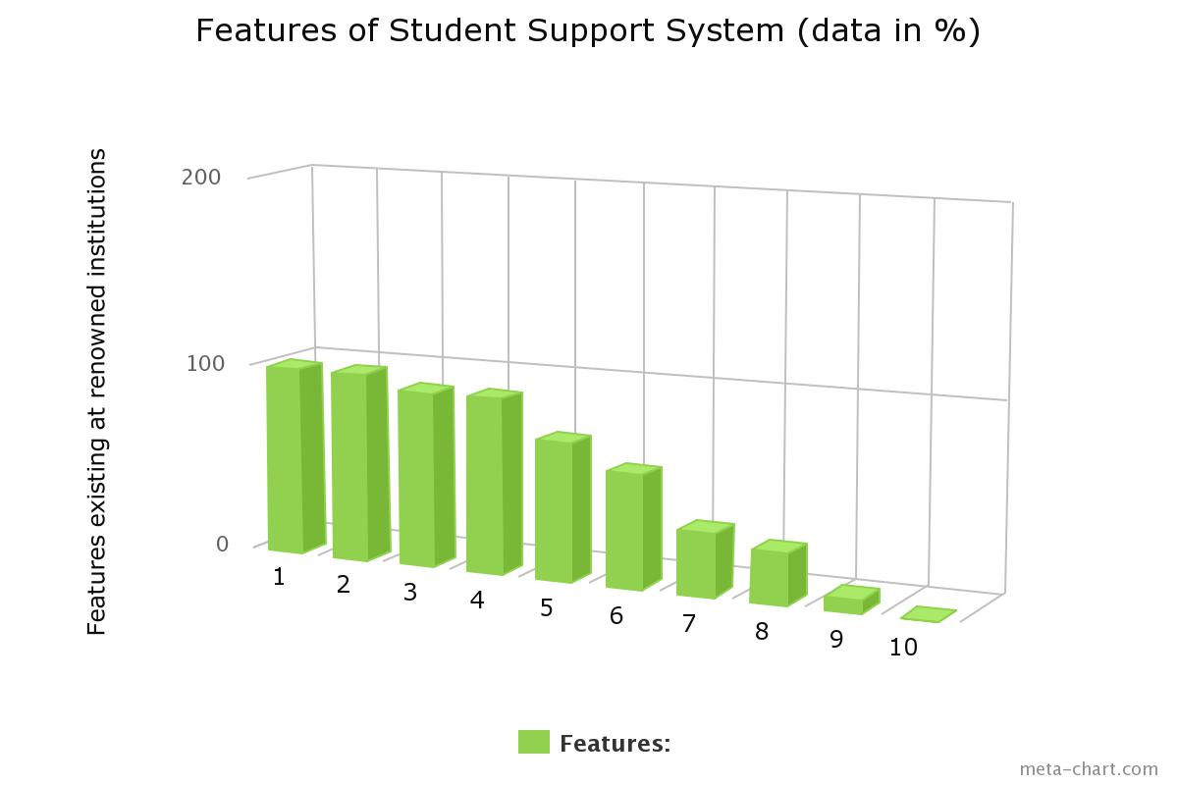

**With respect to above graph:**

1. Anti ragging committee
2. Infrastructure
3. Placement cell
4. Internship
5. Administration
6. Scholarship and fellowship
7. Skill/personality development cell
8. Health
9. Women cell
10. Sexual harassment cell **(src..4)**

*fig(1) website of Jiwaji University as on Feb’09,2015*

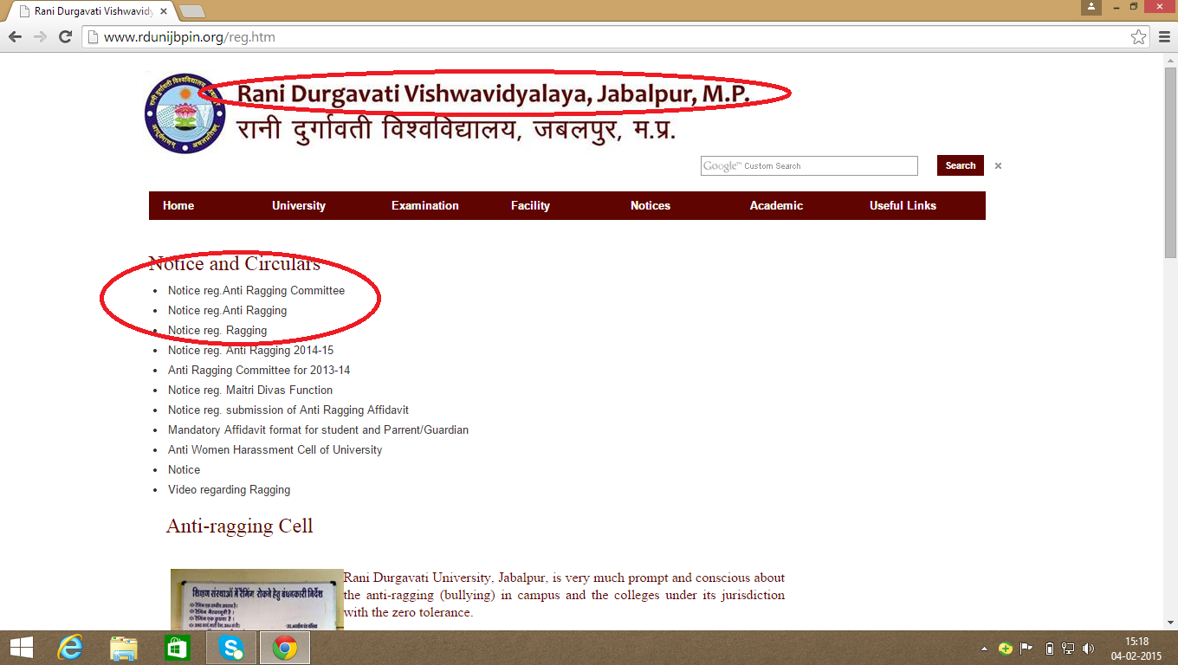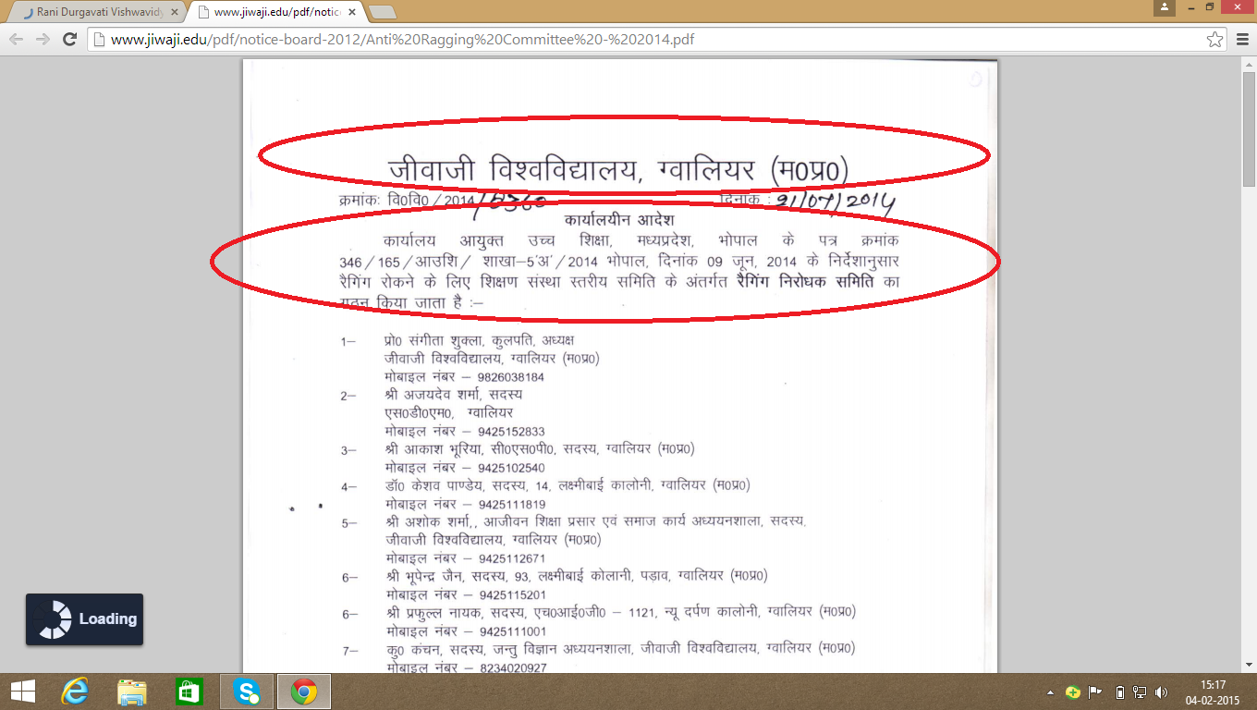

*fig(2)website of Rani Durgavati College as on feb’09,2015*

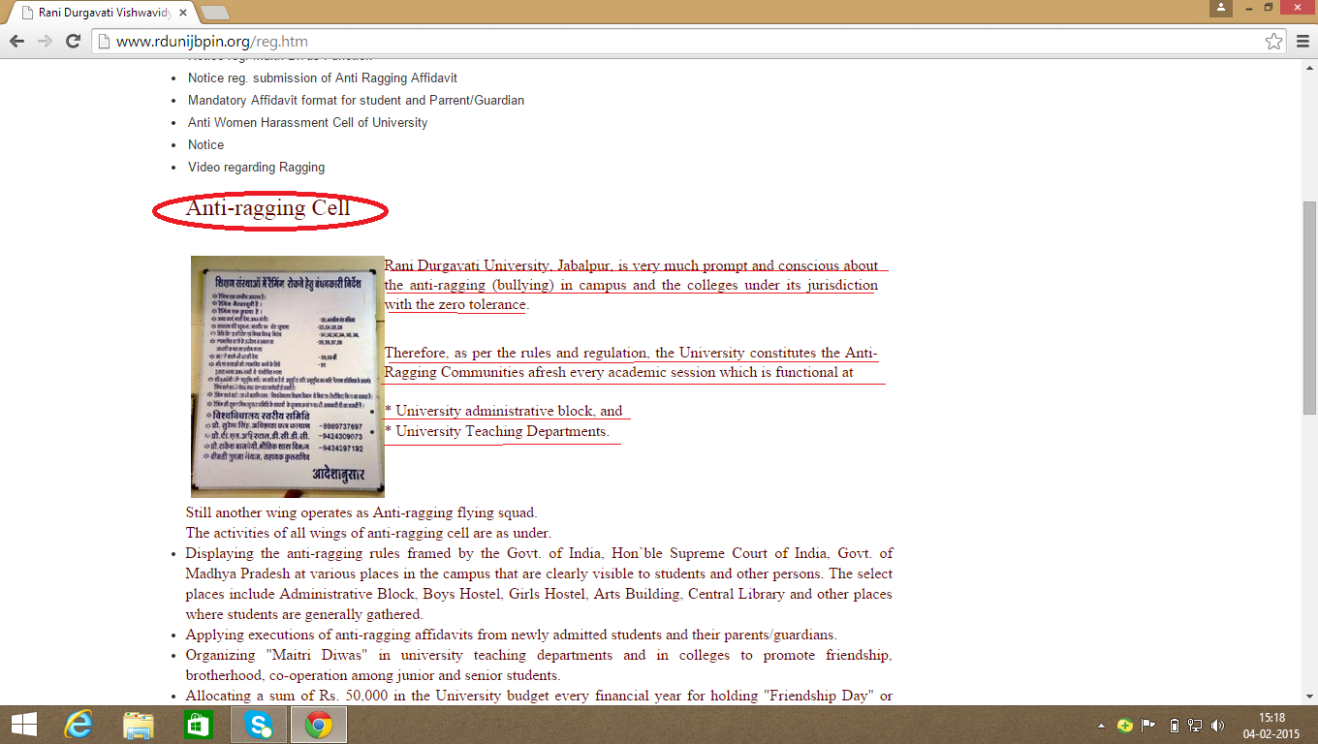

*fig(2.1)website of Rani Durgavati University as on feb ’09,2015*

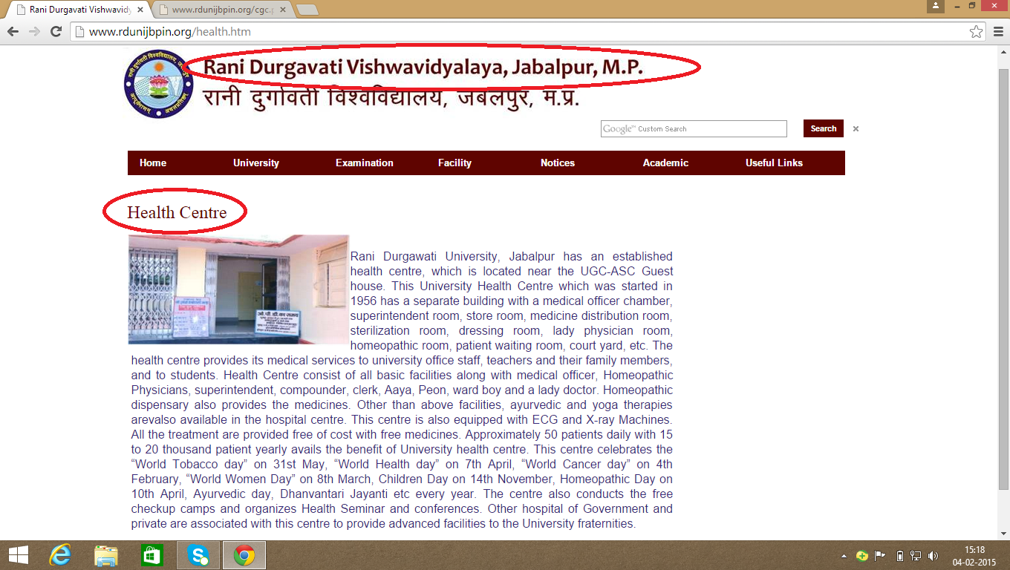

*fig(2.2)website of Rani Durgavati University as on feb’09,2015*

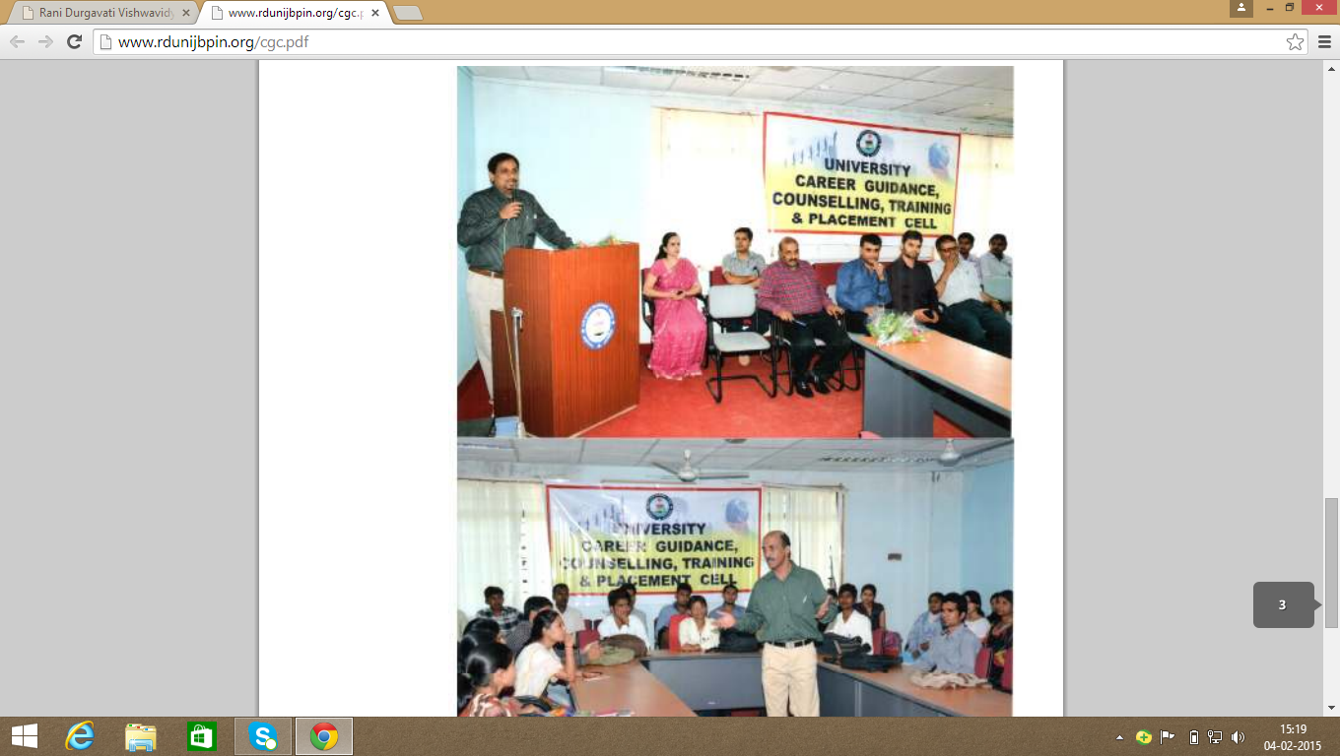

*fig(3.1)website of Jaypee College of engineering as on feb’09,2015*

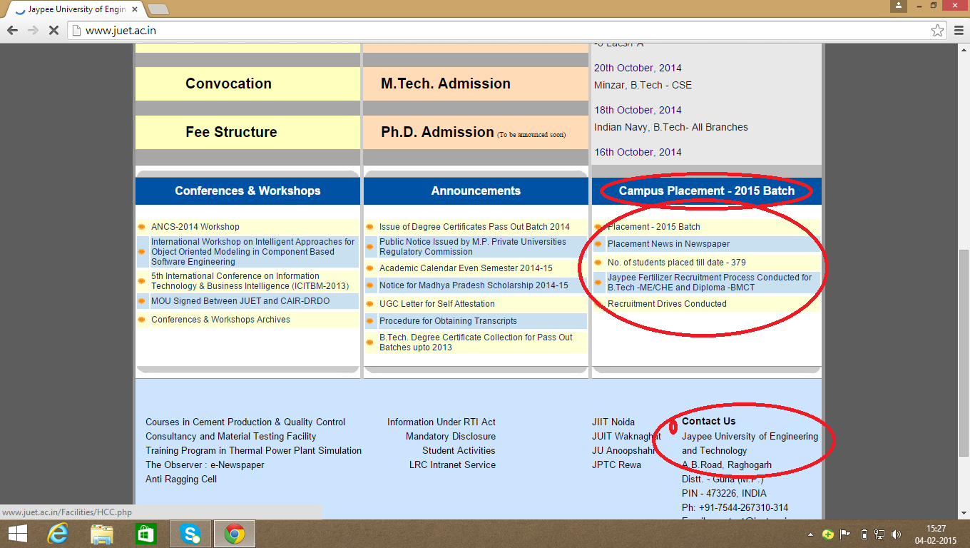

*fig(3.2)website of Jaypee college of engineering as on feb’09,2015*

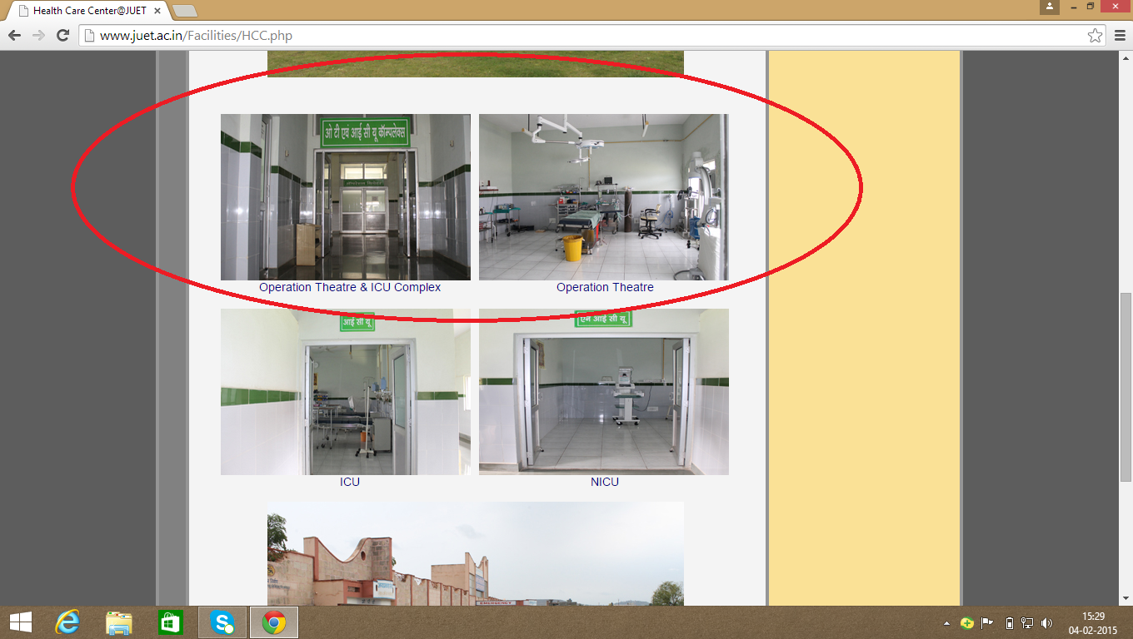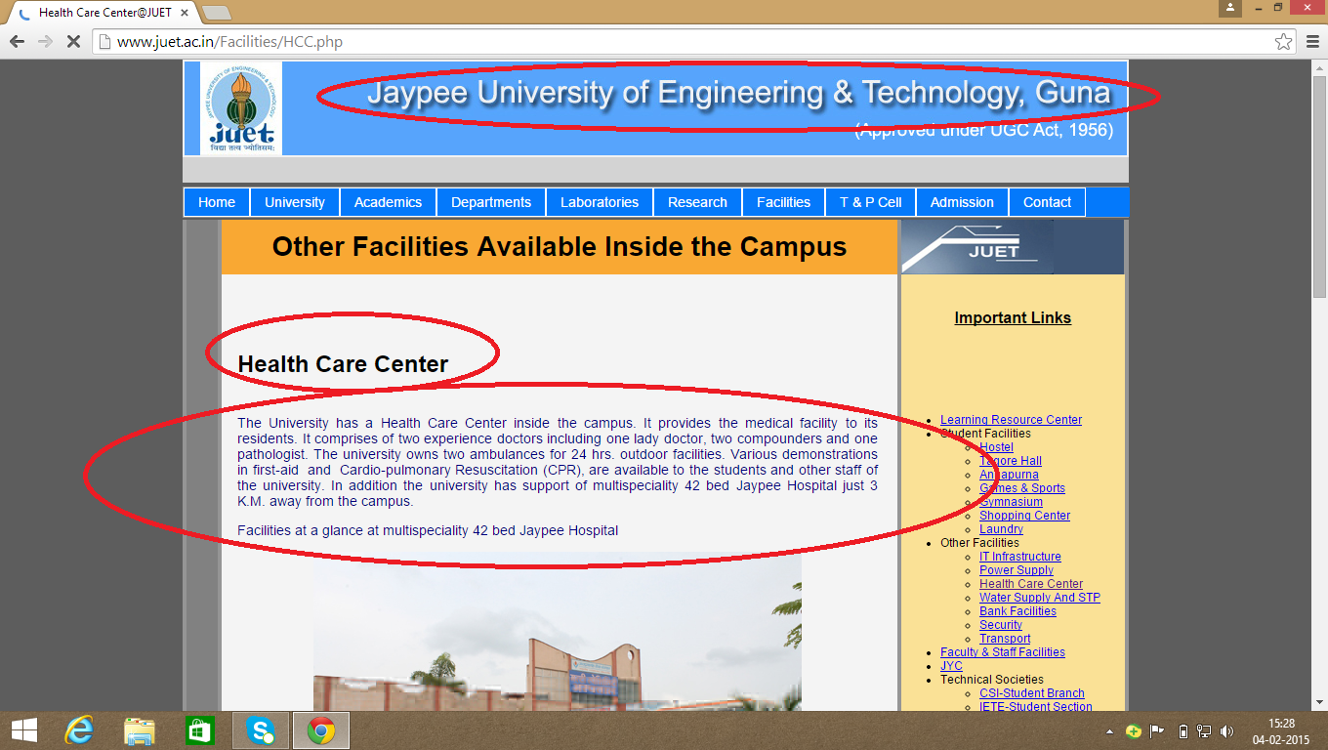

*fig(3.3)website of Jaypee college of engineering as on feb’09,2015*

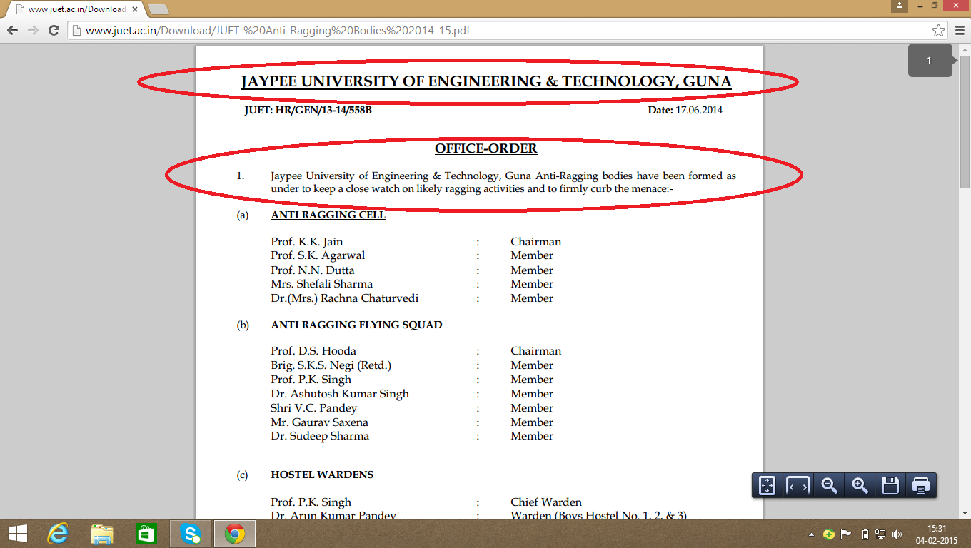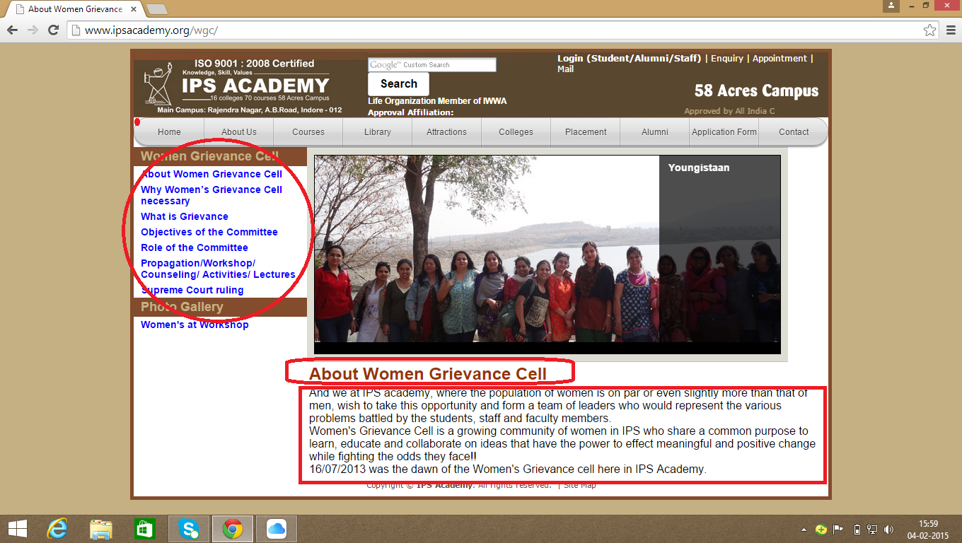

*Fig(4)website of ips academy as on feb’09,2015*

*fig(5)website of Indira Gandhi engineering college as on feb’09,2015*

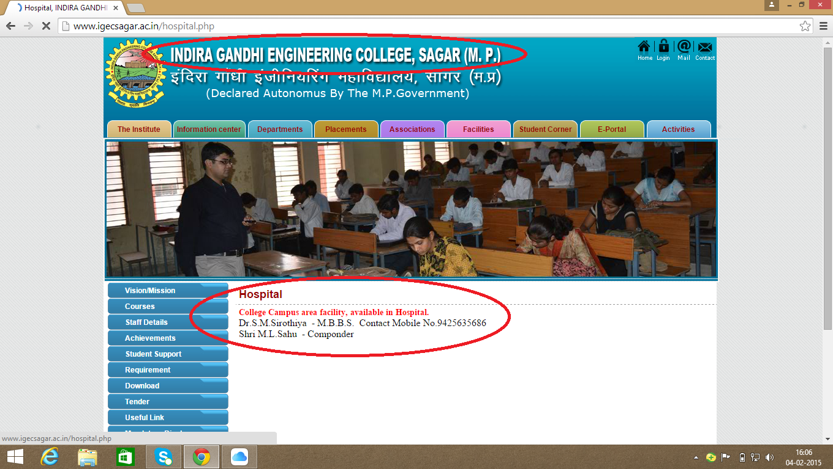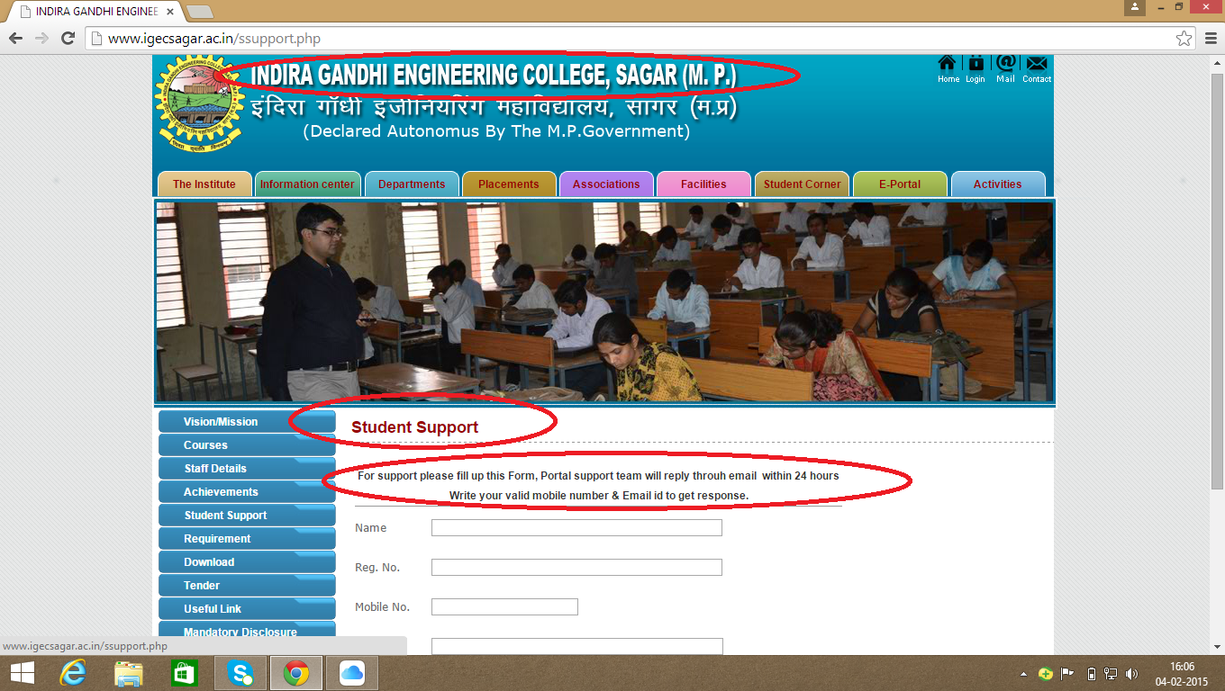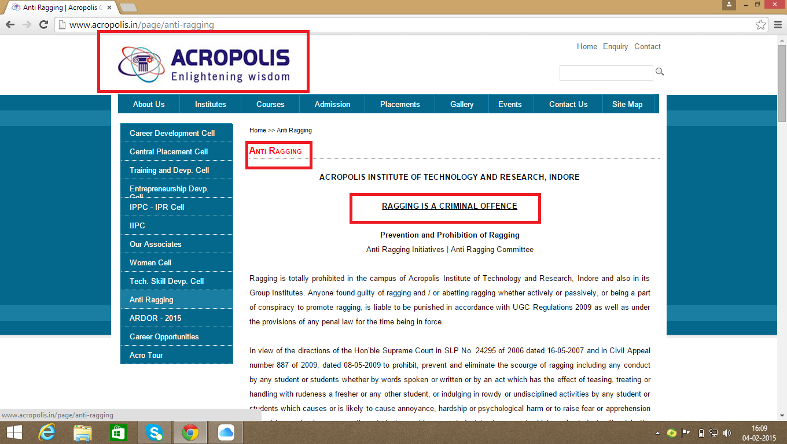

*Fig(5)website of Acropolis college as on feb’09,2015*

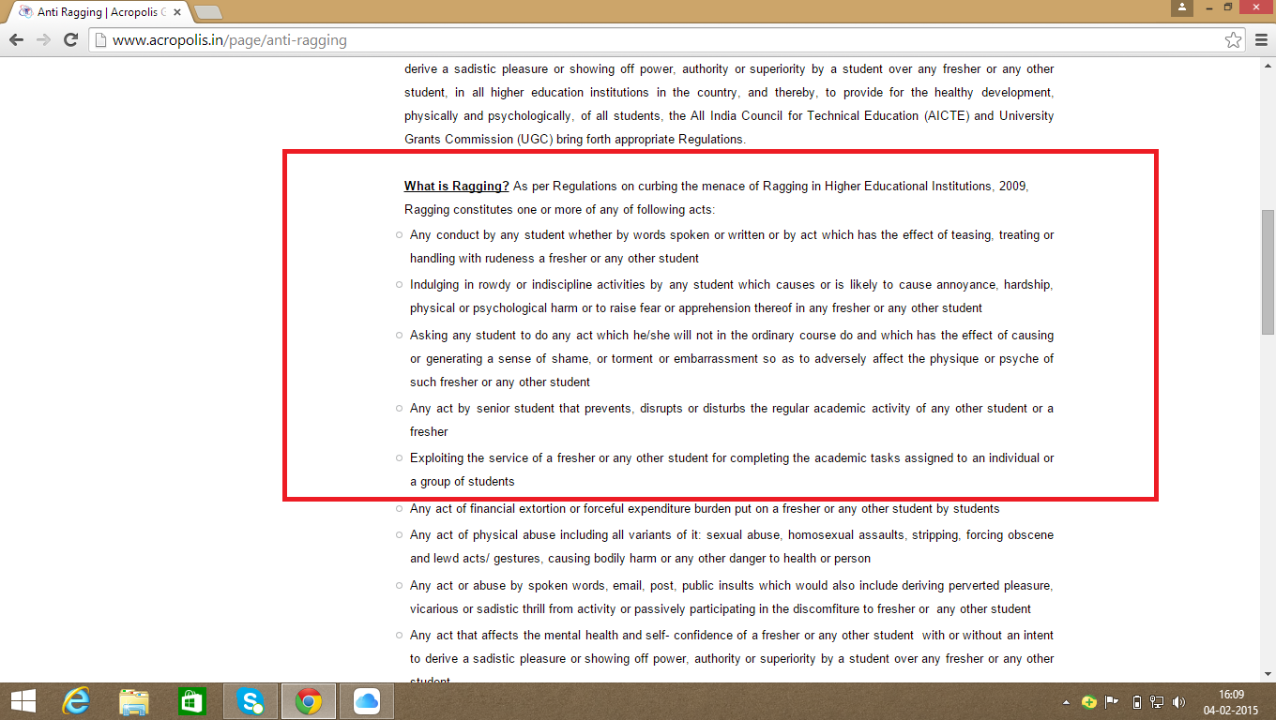

*Fig(5.1)website of acropolis college as on feb’09,2015*

*fig(5.3)website of acropolis college as on feb’09,2015*

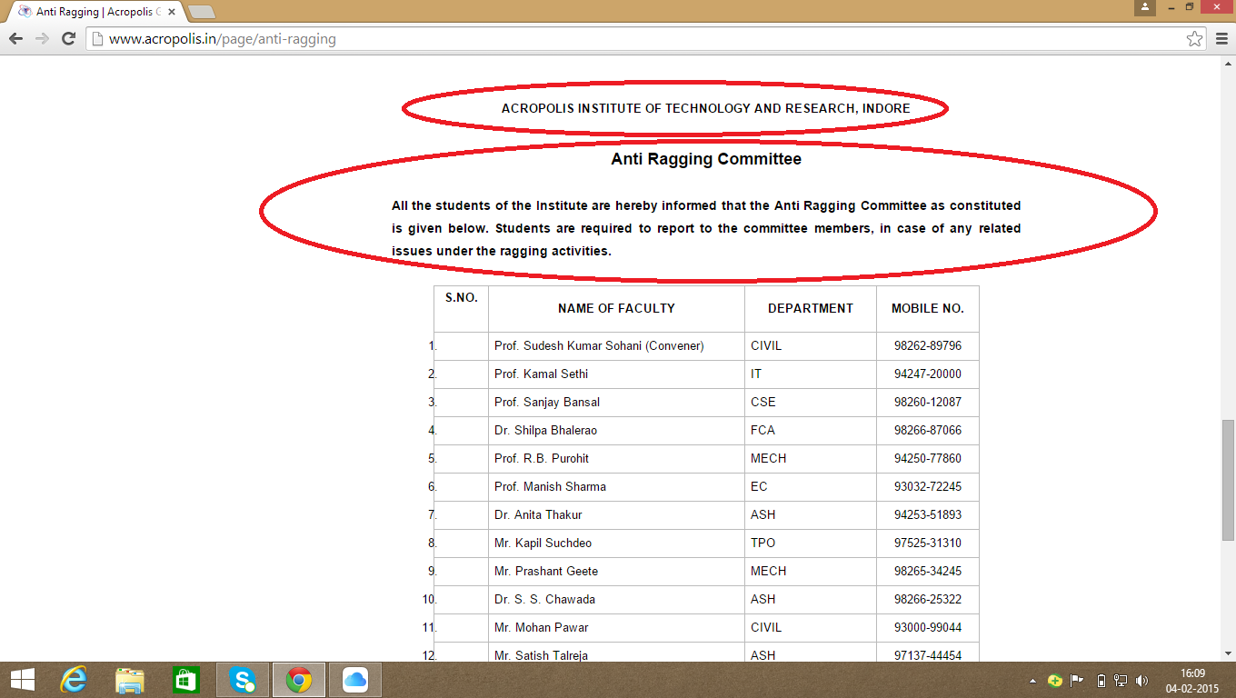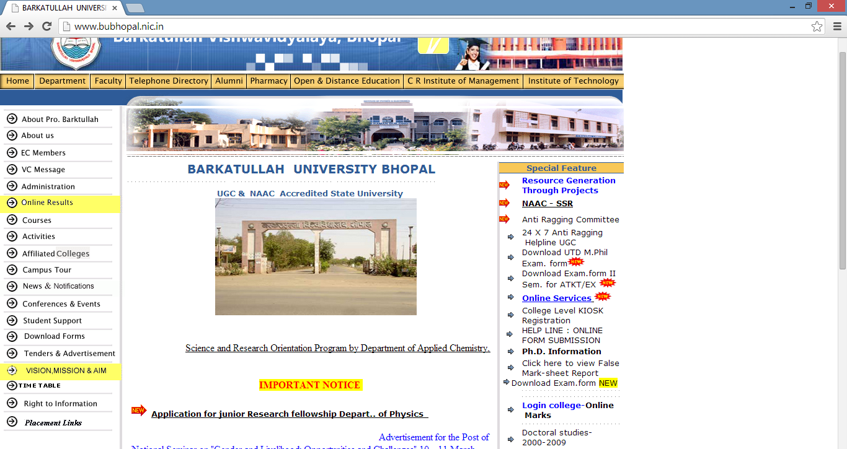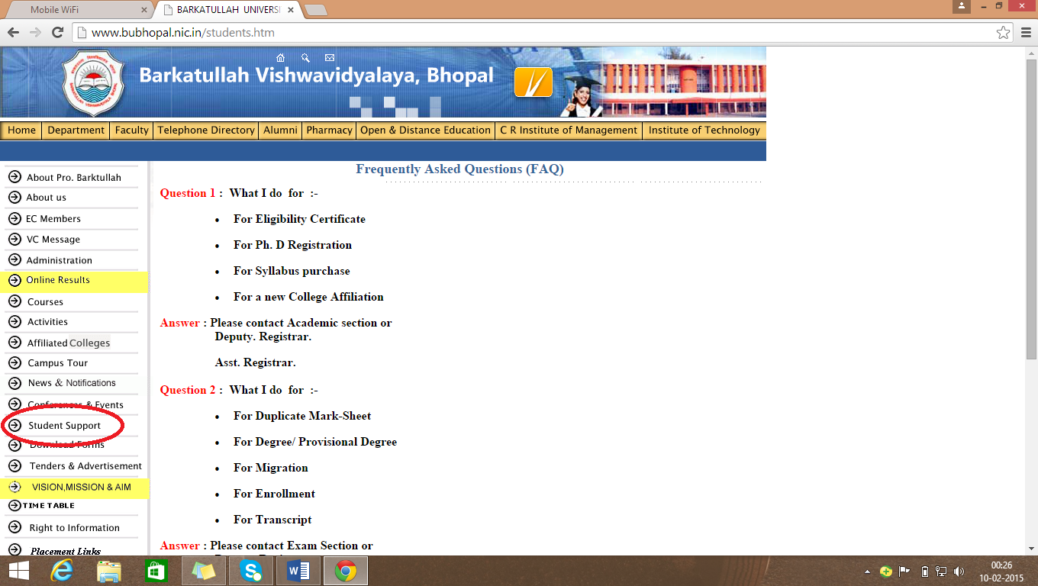

*Fig(6)website of Barkatullah University as on feb’09,2015*

Administration

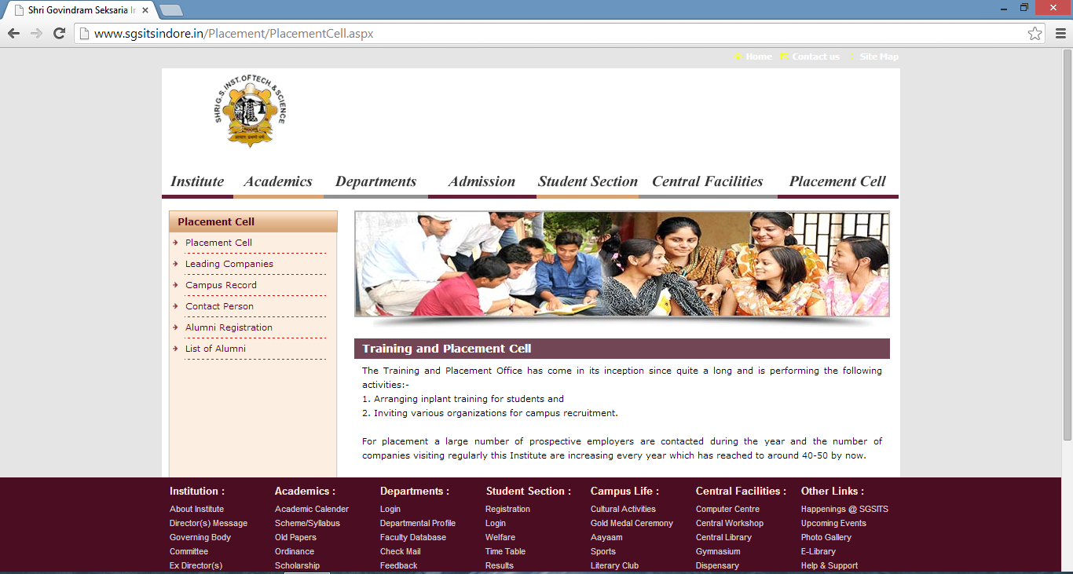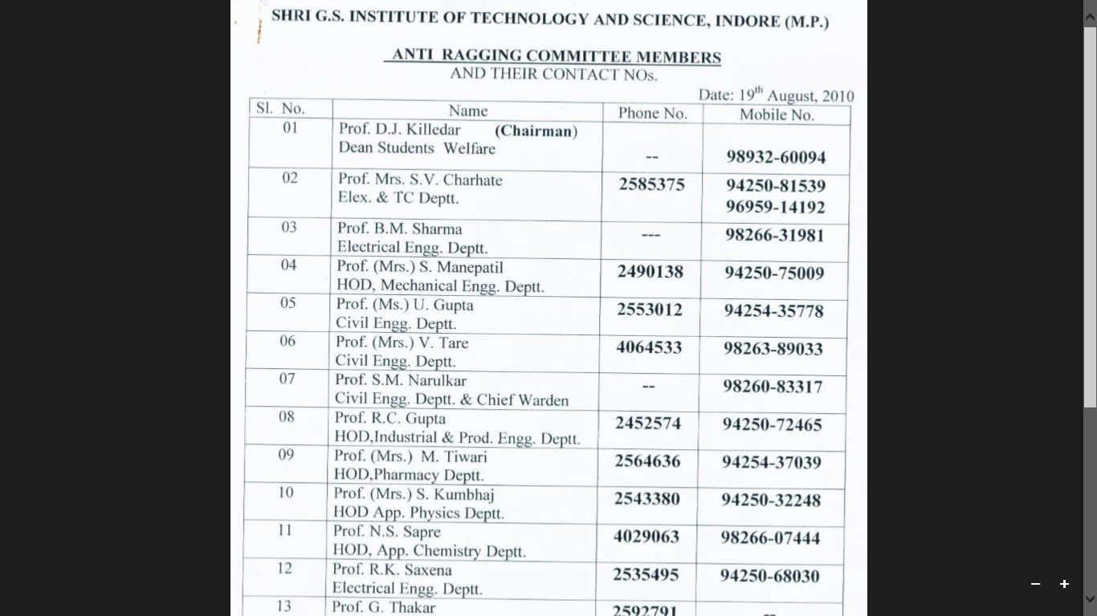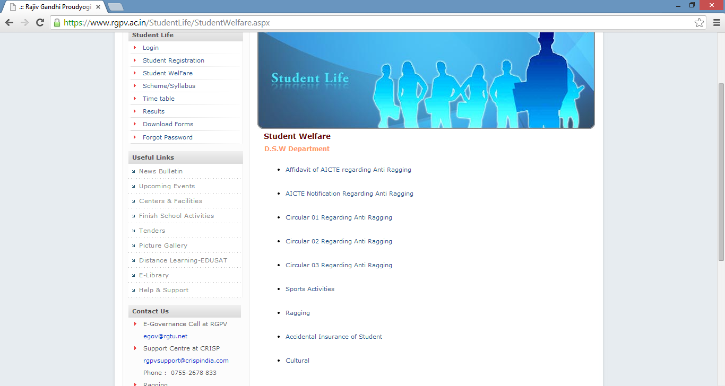

Encrypted version unavailable

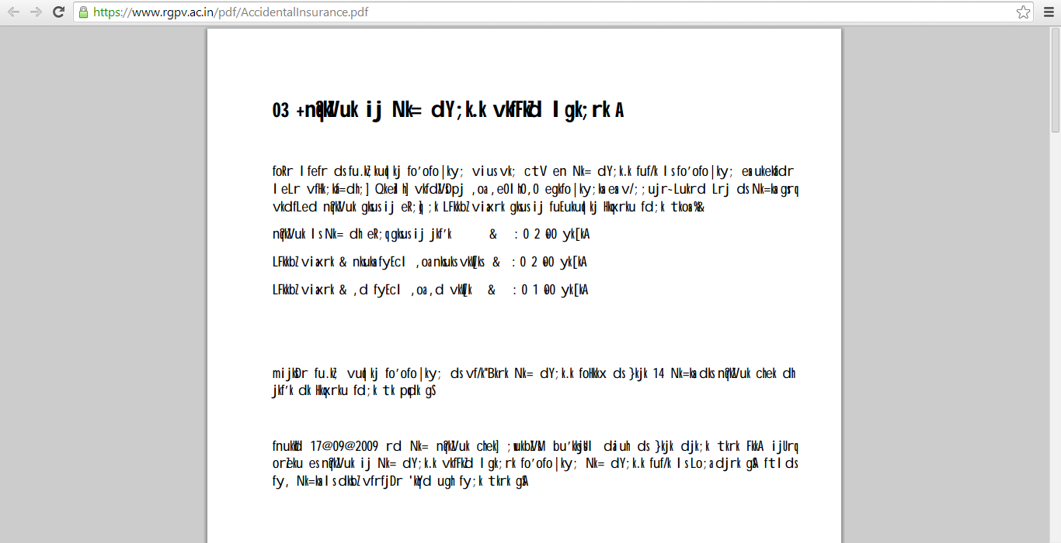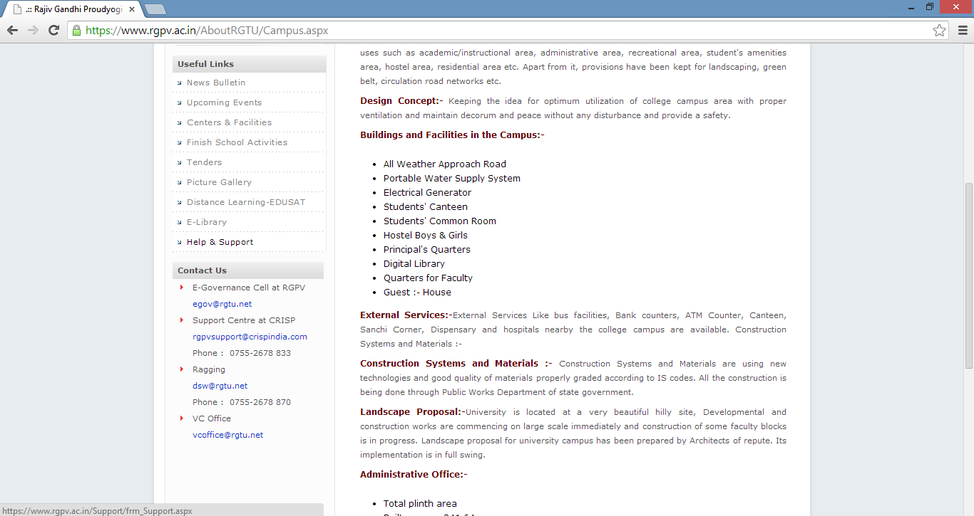

Infrastructure

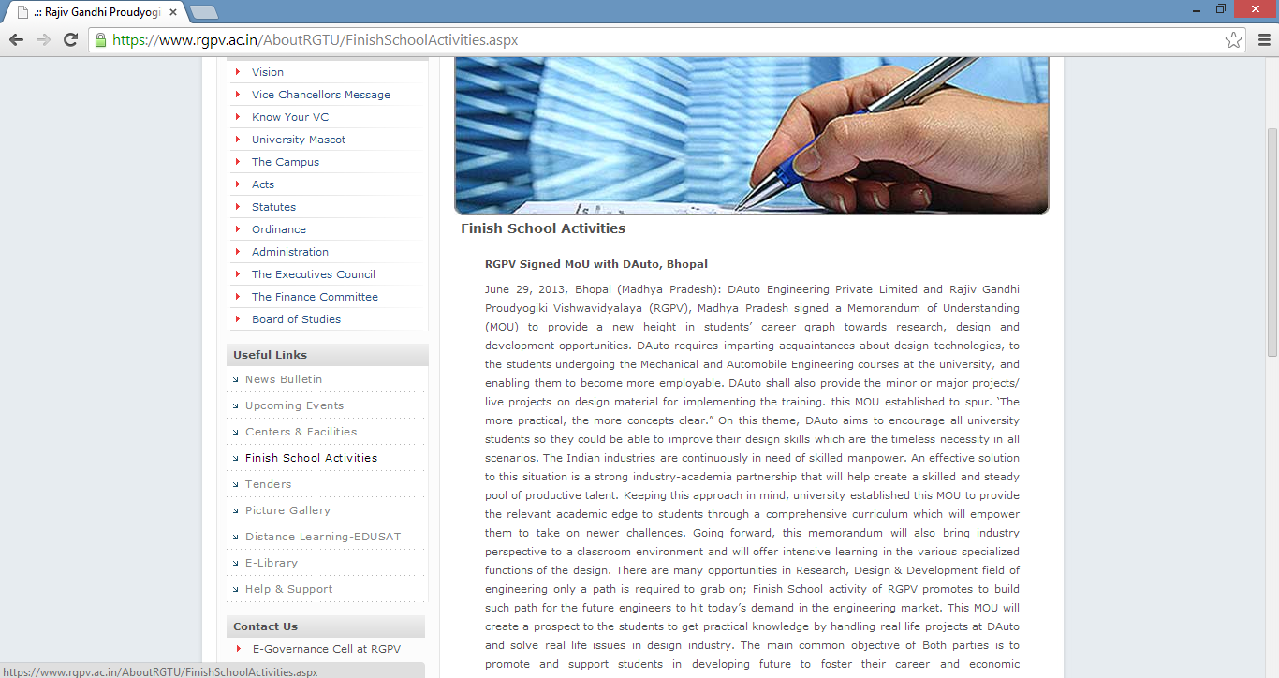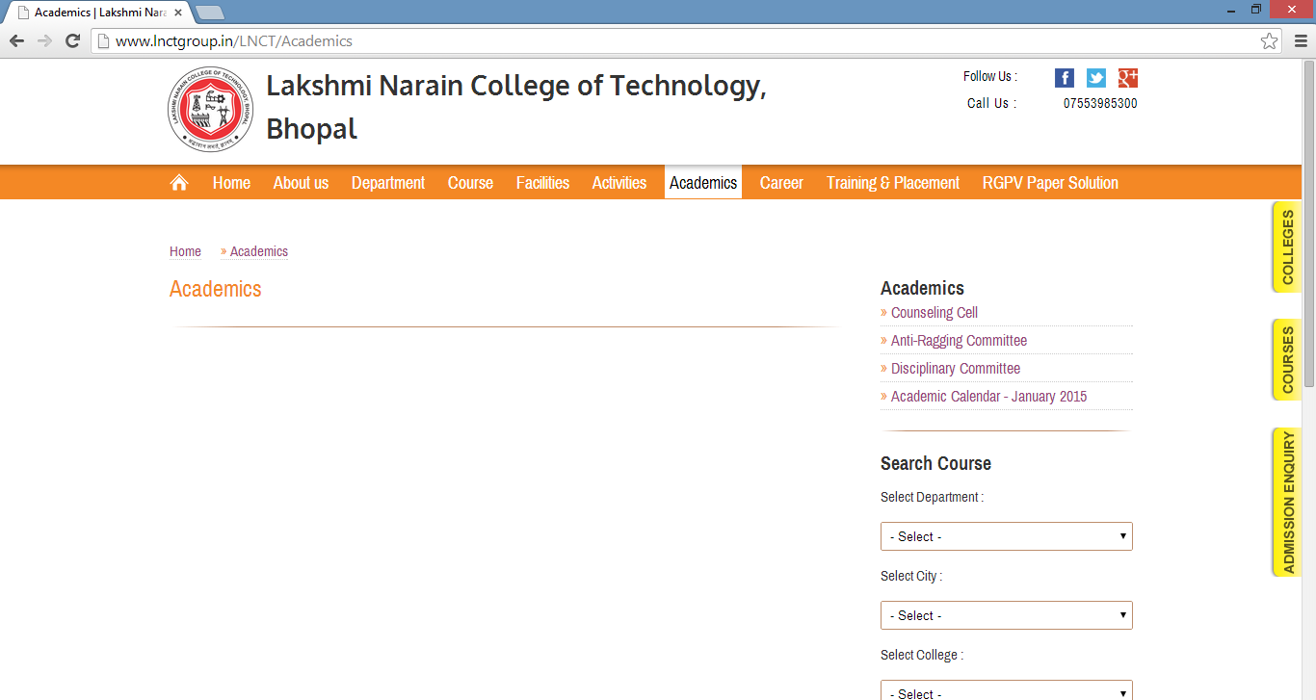

Infrastructure

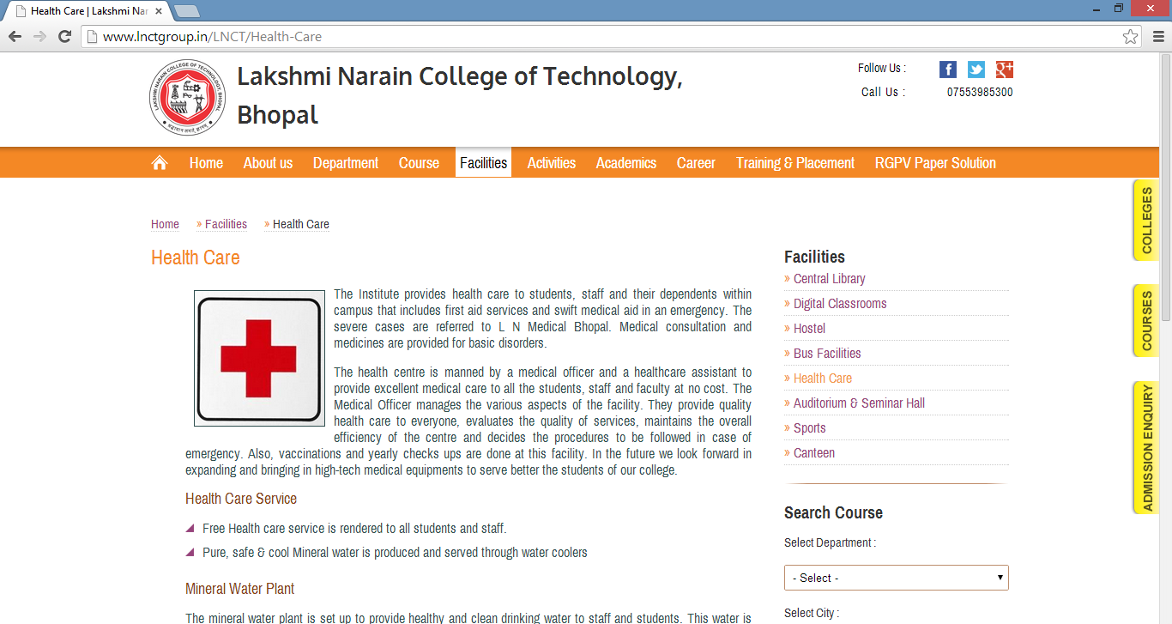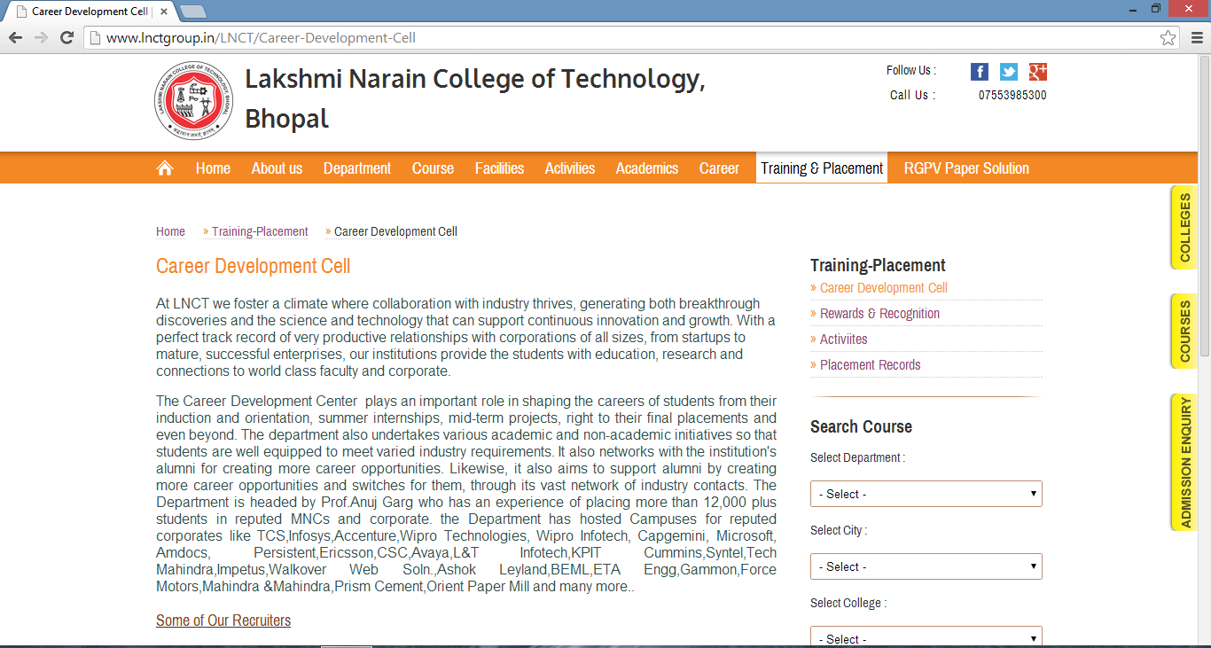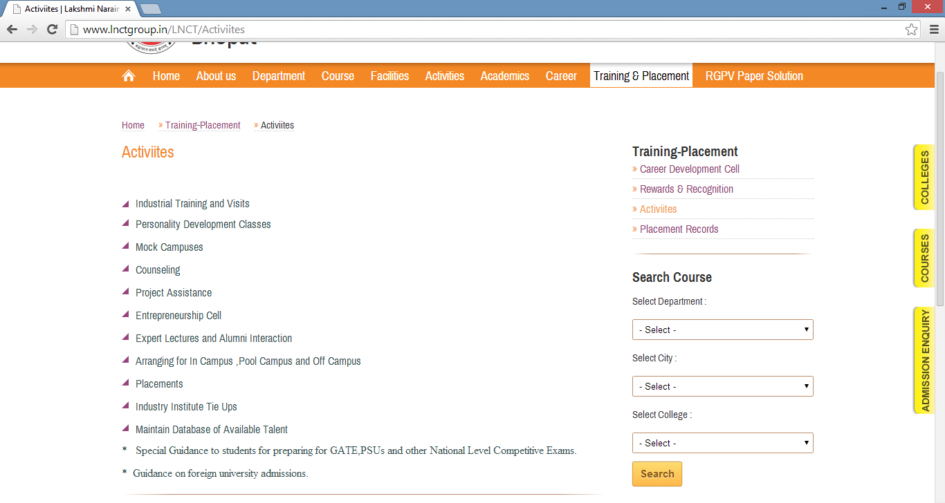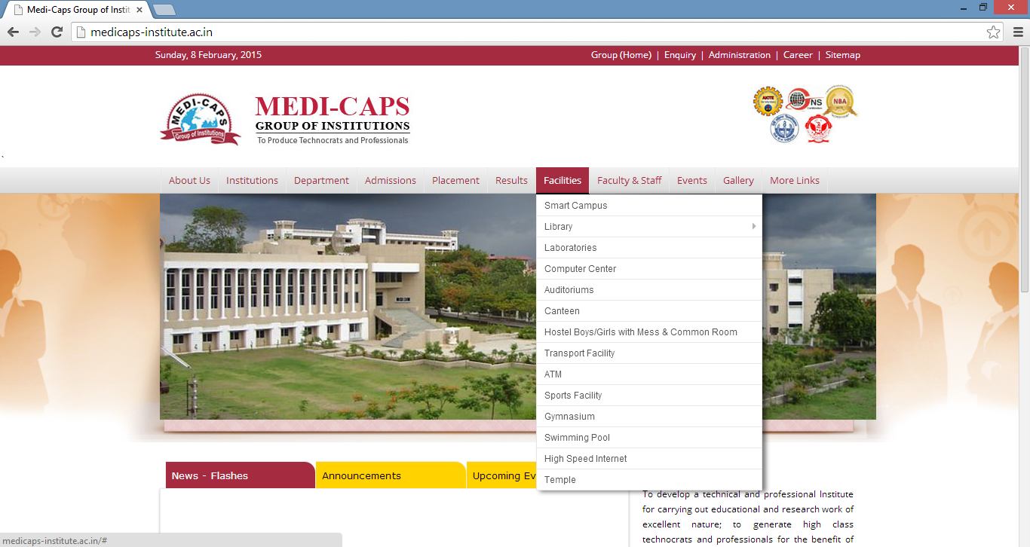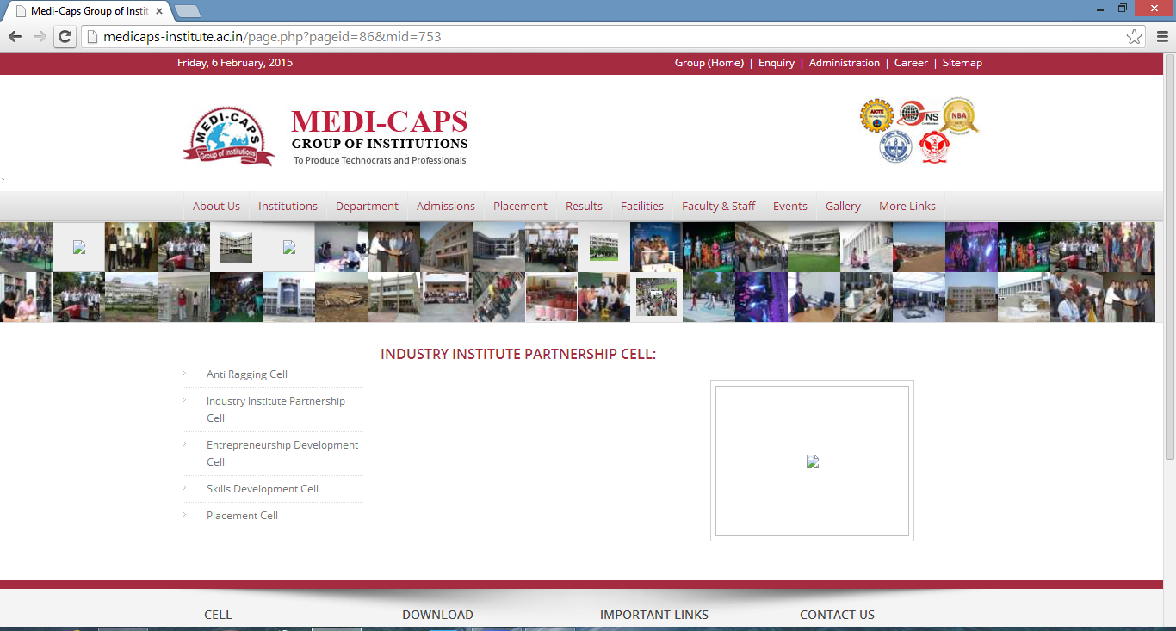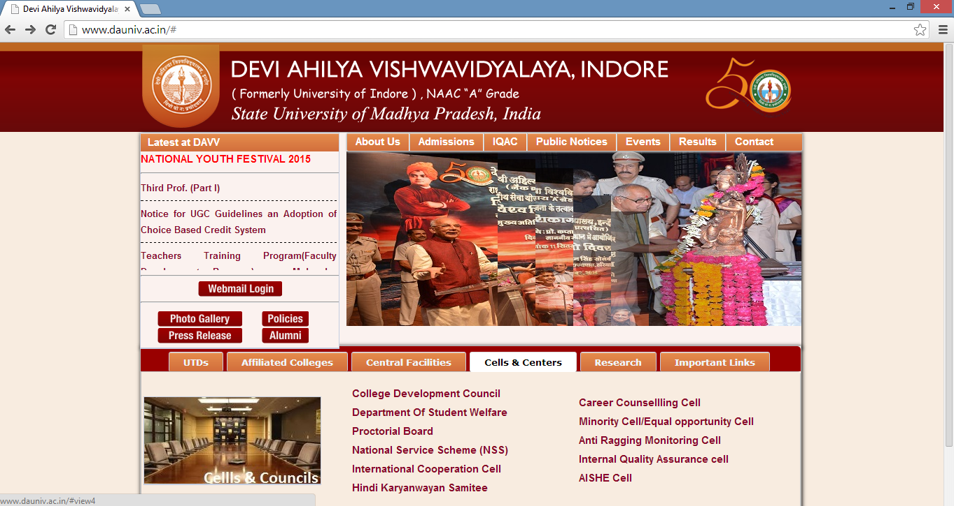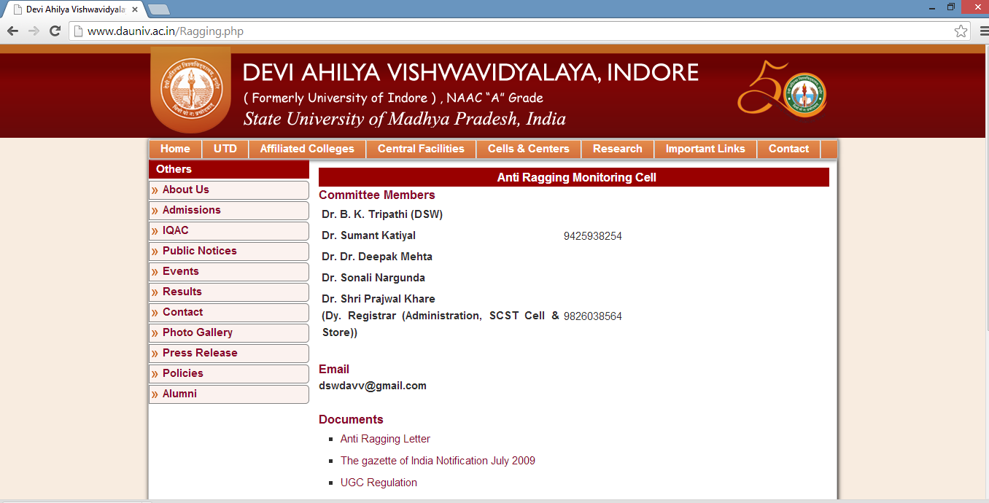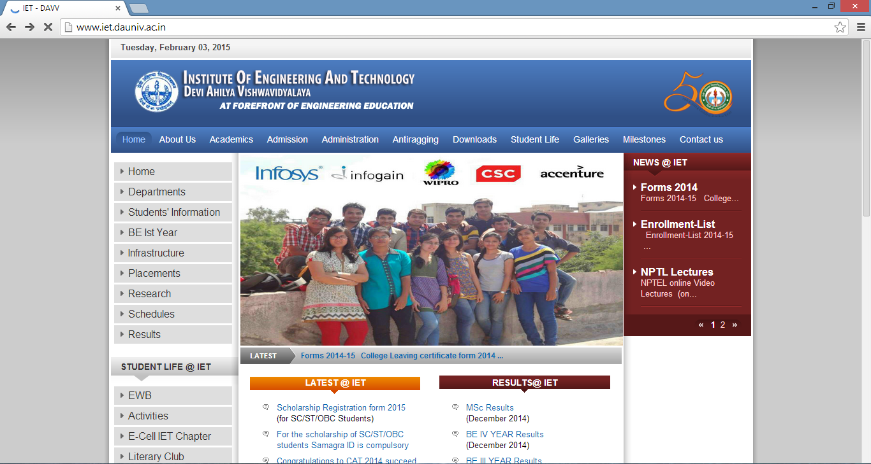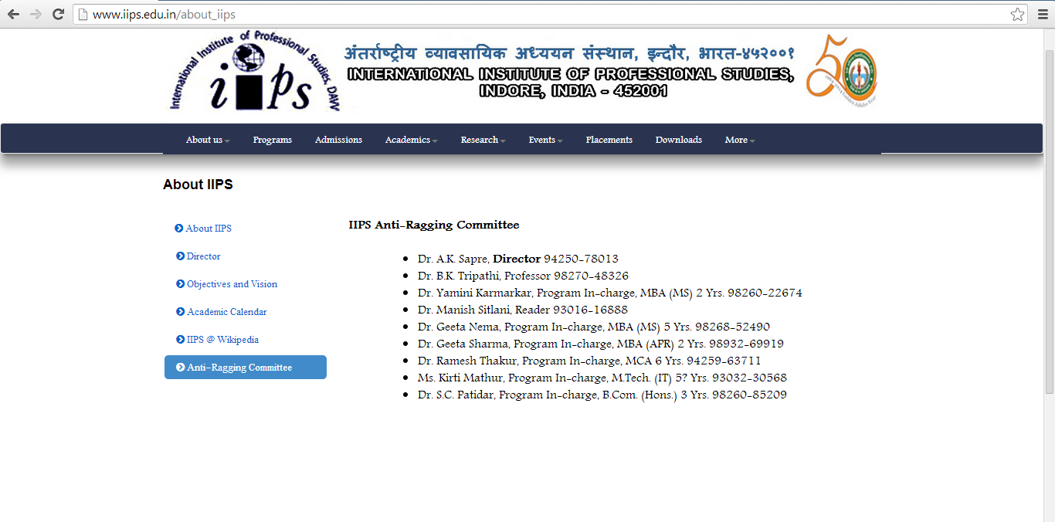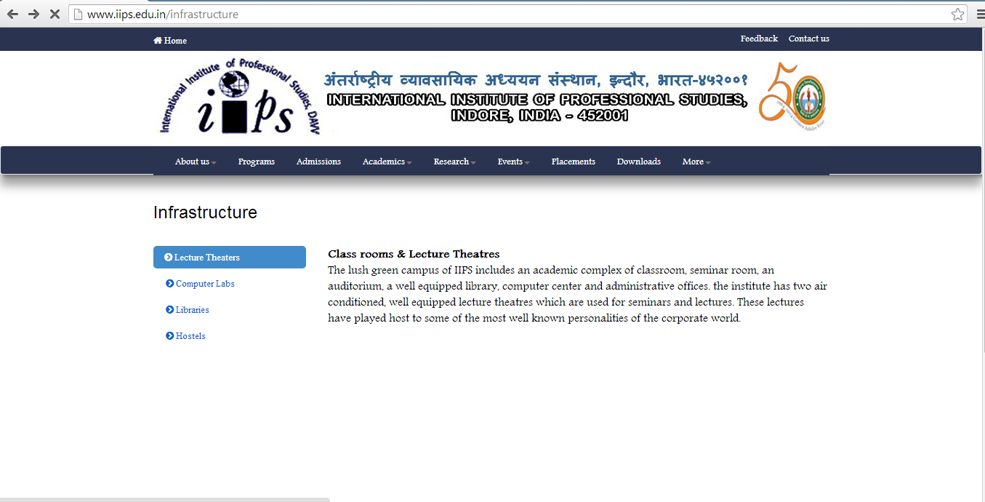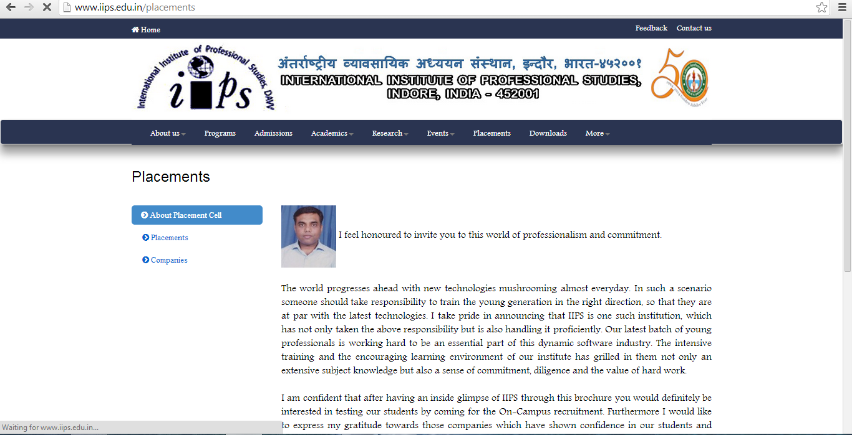

*Fig(7) website of IIPS,Indore as on feb’09,2015*

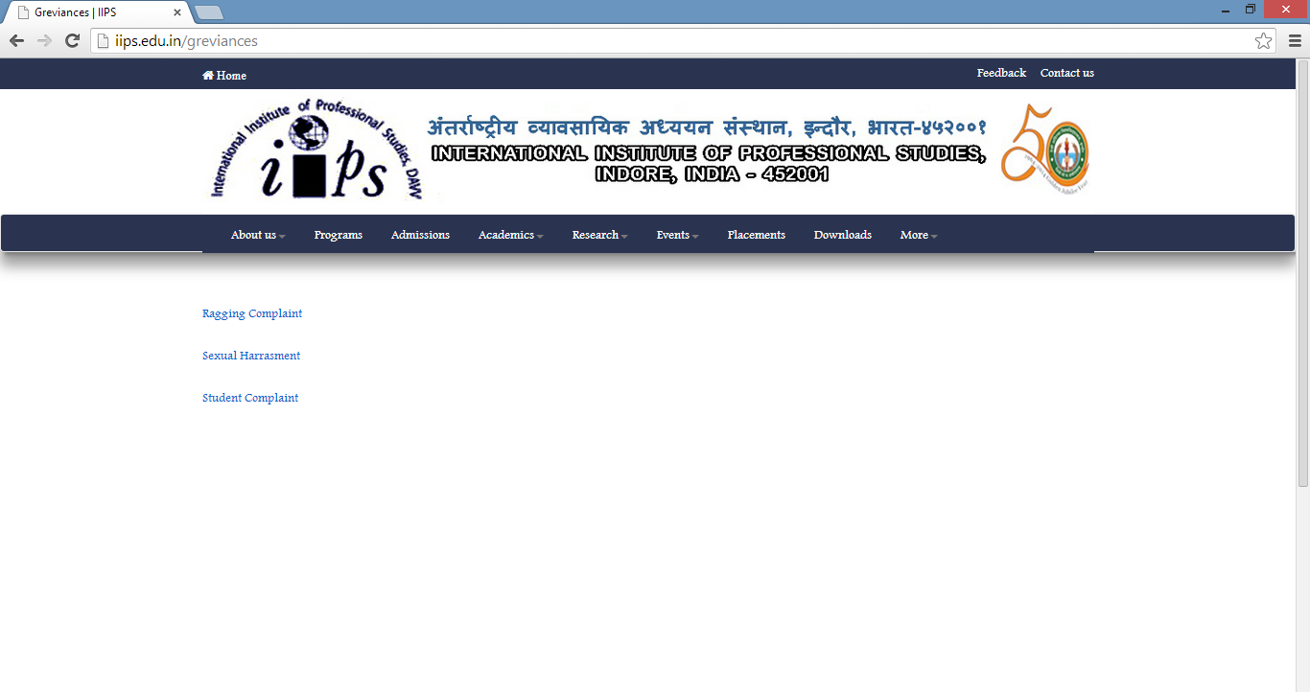

All the three links direct us to this page

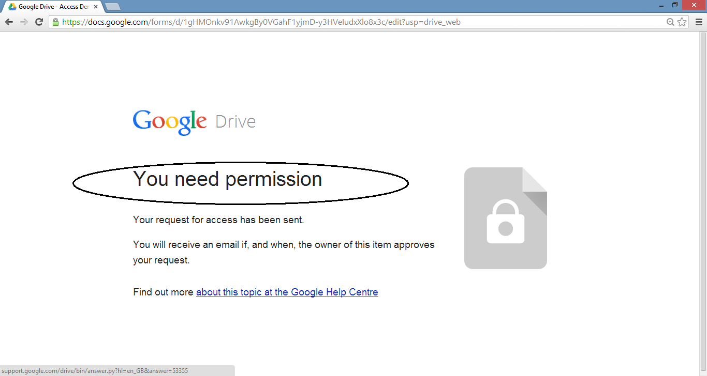

**Chapter 2**

**Shortcomings/limitations of current IIPS website**

Grievances section includes

* Ragging complaint
* Sexual harassment
* Student complaint

All the three sections directs us to log in through our e-mail id and then our request is sent to the owner.When it is granted,an approval e-mail is sent to us and then we can lodge our complaint.

**Limitation :**

This process is tedious and time taking and is definitely not fruitful because anyone who is in need will not be able to get help at the very moment.

Rather the suggestions in the next chapter must be implemented to actually solve such grievances. **(src..5)**

**Suggested sections/features for Student Support System of IIPS website**

[**(http://iips.edu.in/)**](http://iips.edu.in/)

**Must implement features**

1. 24*7 anti ragging helpline
2. Women cell with 24*7 separate helpline (especially for those in hostel)
3. Information about scholarships to keep transparency as well (In this section work of **SGSITS,Indore** is commendable)
4. Health center/hospital must be in the university(DAVV) campus with ambulance facility and an emergency helpline number on the website
5. Skill development and personality development cell
6. Information about college administration
7. Student profiles/records must be updated as soon as possible (which is under progress)

**(src..6)**

**Chapter 3**

**MANIT as a model for the prevalent Institutes of Madhya Pradesh**

We chose *Maulana Azad National institute of technology* *,Bhopal* as a model to quote an example from for an ideal institute or to highlight some of the world class features which MANIT possess which could serve as a basis to set a benchmark in the education Field.

Some of the underlying features supported by snapshots of the respective website of MANIT :-

* 24*7 Anti Ragging Helpline
* Wide Range of Security Services inside the Institute Premises
* All the required and necessary Health Facilities including escort service to the respective Hospital
* World Class Infrastructural facilities including Campus wifi and uninterrupted internet connectivity
* Dispensary under the respective recognition of reputed Doctors
* Skill Development & placement Cell **(src..7)**

***Snapshots of the website of MANIT,Bhopal as on feb’09,2015 are provided underneath***

|  |  |  |
| --- | --- | --- |
| **MANIT**  *(National Institute of Technology,Bhopal)*  ***Considered as a Model For the prevalent Institutes of Madhya Pradesh having all the basic amenities an ideal institute should possess*** | 1960 | * ***Anti Ragging Helpline(24*7)*** * *Placement Cell* * *Infrastructure* * ***Health*** * *Scholarship & Fellowship* * *Internship* * ***Sexual harassment Helpline*** * ***Women Cell*** * *Skill Development Cell / personality development* * ***Administration*** * Admissions * Safety &security * Maintenance of student Records |

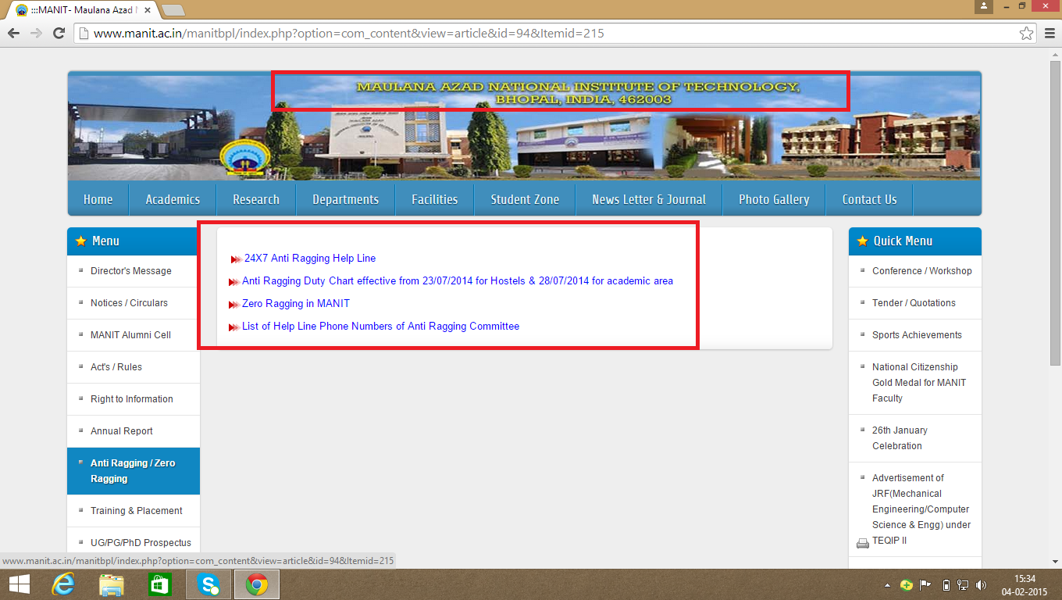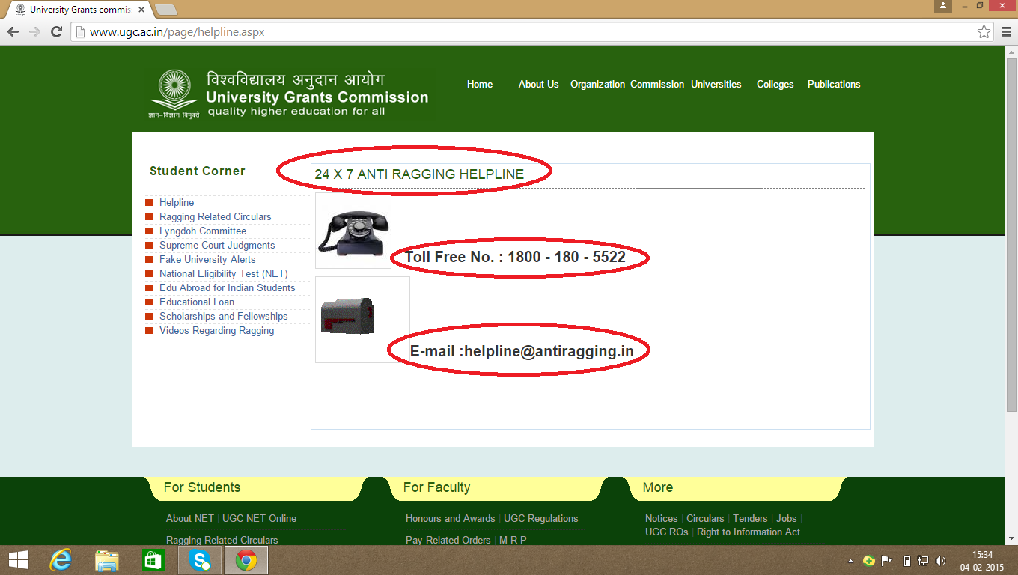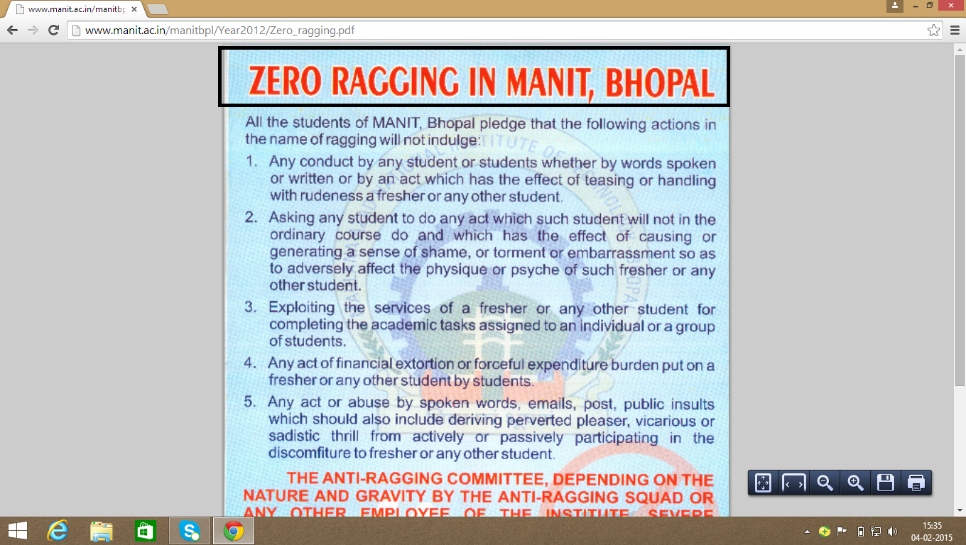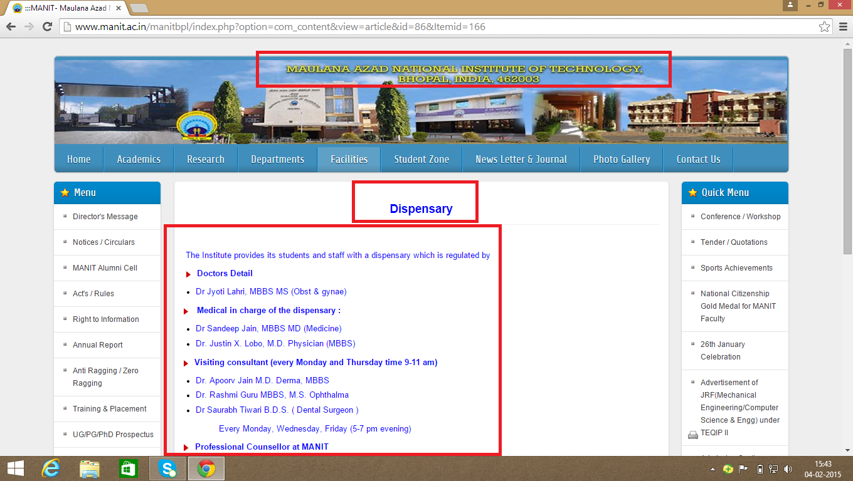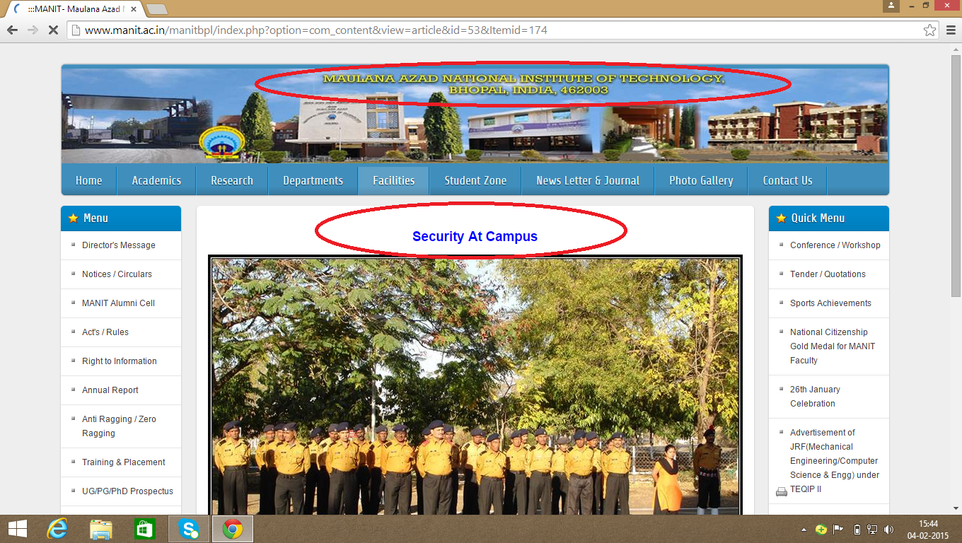

**Chapter 4**

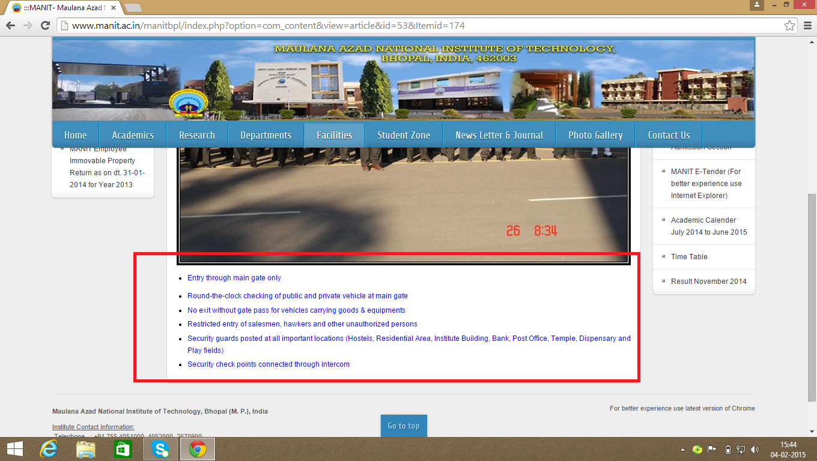

***Reason behind choosing Anti Ragging as a basis for app building activity***

As we could see through the survey conducted by us whose details have been mentioned above in a tabular format ,Anti Ragging has been included by almost each and every educational institution considering ragging to be a too sensitive issue in India which needs to be eradicated at the earliest.

*Some of the dreary effects/consequences of ragging and what the term ‘ragging’ signifies has been worked upon below along with a statistical data portraying how ragging affected the youth lately.*

*Through our analysis we could come to a conclusion that though ragging has been mentioned on the respective websites of renowned institutions in the form anti ragging squads and cells mostly covering the following features :-*

* Anti ragging squad containing a few faculties as its members
* Listing of severe punishments
* Contact details of the individuals involved in the squad

***What more, thus effective needs to be done***

The efforts of the inclusion of ‘anti ragging’ cells is though appreciable but certainly lack some of the effective measures which could have been incorporated in order to aim zero ragging inside the premises of the respective institution :-

**Suggestions :-**

* Provision of contact details of each and every individual involved in the squad could be tedious as well as uncertain at times thus the need of the hour is the inclusion of **anti ragging helpline number** which should work as toll free as well as on **24*7** basis since Ragging has been considered as a delicate issue for an individual to cope up with.
* **Special counselling** concerning motivation on steps dealing with the victims of ragging or providing necessary steps on **‘how to curb ragging on an individual basis’ (src..8)**

***Model For the Proposed System***



***Anti Ragging selected amongst features for an ideal institute as a basis for app building***

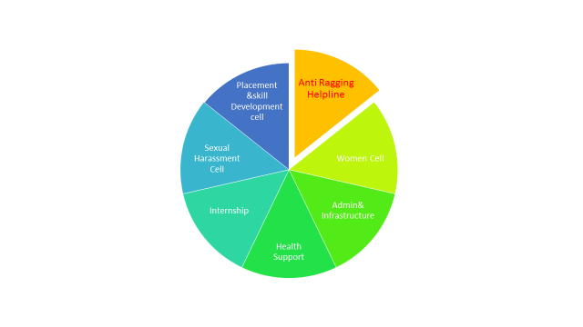

|  |
| --- |
| ***Statistics of Ragging Cases in India including Madhya Pradesh (src..9)***  **Ragging** is a damaging form of interaction of the seniors in college or school with the juniors, newcomers or first years. It is similar to but not the same as [hazing](http://en.wikipedia.org/wiki/Hazing) in the United States, it is not an initiation. It involves insults (simple or suggestive sexual, sarcastic and even physical), running errands for seniors, and many other complex activities. Highly reputed Indian colleges have a wistful history of [ragging](http://en.wikipedia.org/wiki/Ragging) especially Medical colleges. It has become increasingly unpopular due to several complaints of serious injury to the victims and strict laws regarding ragging. Ragging is now defined as an act that violates or is perceived to violate an individual student's dignity.    *Ragging shatters the future of the victim and also the dreams of their parents and the accused cannot pursue the course thereafter.* ***(src..10)*** |
| **RAGGING AND ITS EFFECTS**  Ragging is not harmless fun. Students come from different social and cultural backgrounds, and what may be harmless fun for some may turn serious human indignity for some other human being. There are number of cases where some cases the fresher’s and ragging intolerable and it leads to loss of self esteem. Ragging some time causes to loss of innocents lives. Effects of ragging on freshers in different ways.   1. Physical injury through beating, hitting by objects or by forcing to perform dangerous tasks *Sexual abuse by forced stripping, masturbation, forced unnatural sex etc.* 2. Psychological trauma generated because of intense fear 3. Human Rights abuse 4. Forceful initiation to alcoholism, smoking and drugs 5. Dropping out from college 6. Group Violence 7. Leads to mob mentality and violent mindset 8. Deaths  **(src..11)**   **RAGGING AND ABUSE OF HUMAN RIGHTS**  Ragging is a traditional and systematical human right abuse in Education and such human right violations in education have not been given proper attention in India, which they otherwise deserve. However, with in United Nation, ragging has been considered as an issue of “Human Rights in education”. Education law in India should take note of practice of ragging in educational system as a major obstacle in realization of the “Right to Education”. Blackstone believed that the principal aim of the society “is to protect individuals **(src..12)** |

***References***

*References of the above mentioned sources through (src) are given underneath :-*

* *(src..1)* [*www.fddiindia.com/aboutus-new/img/Grievance_Redressal.pdf*](http://www.fddiindia.com/aboutus-new/img/Grievance_Redressal.pdf)
* *(src..2 )* [*www.fddiindia.com/aboutus-new/img/Grievance_Redressal.pdf*](http://www.fddiindia.com/aboutus-new/img/Grievance_Redressal.pdf)
* *(src..3)* *) http://www.careerindia.com/news/2013/05/09/ugc-help-students-with-grievance-redressal-mechanism-004927.html*%20http:\www.careerindia.com\news\2013\05\09\ugc-help-students-with-grievance-redressal-mechanism-004927.html)
* *(src..4 )Self written based upon the Survey*
* *(src..5) Self written based upon the Survey*
* *(src..6) Self written based upon the Survey*
* *(src..7) Self written based upon the Survey*
* *(src..8) Self written based upon the Survey*
* *(src..9)* [*https://www.google.co.in/url?sa=i&rct=j&q=&esrc=s&source=images&cd=&cad=rja&uact=8&ved=0CAYQjB0&url=http%3A%2F%2Fwww.nscbip.org%2F%3Fp%3D1&ei=Xj7mVLvLE8KD8gXGp4DoDA&bvm=bv.85970519,d.dGc&psig=AFQjCNFY_fgGjTO7NK001v0Bgw7oI7Cprg&ust=1424461749181403*](https://www.google.co.in/url?sa=i&rct=j&q=&esrc=s&source=images&cd=&cad=rja&uact=8&ved=0CAYQjB0&url=http%3A%2F%2Fwww.nscbip.org%2F%3Fp%3D1&ei=Xj7mVLvLE8KD8gXGp4DoDA&bvm=bv.85970519,d.dGc&psig=AFQjCNFY_fgGjTO7NK001v0Bgw7oI7Cprg&ust=1424461749181403)
* *(src..10)* [*http://en.wikipedia.org/wiki/Ragging_in_India*](http://en.wikipedia.org/wiki/Ragging_in_India)
* *(src..11) )* [*http://en.wikipedia.org/wiki/Ragging_in_India*](http://en.wikipedia.org/wiki/Ragging_in_India)
* *(src..12) )* [*http://en.wikipedia.org/wiki/Ragging_in_India*](http://en.wikipedia.org/wiki/Ragging_in_India)